**Question#:1**

How can the value be configured for each of the three arguments (one "In", one "Out", and one "In/Out") in the Arguments window of the Invoked Workflow?

A. In: Variable or Hard-coded value  
Out: Variable or Hard-coded value  
In/Out: Hard-coded value only

**B. In: Variable or Hard-coded value  
  
Out: Variable only -  
In/Out: Variable only**

C. In: Variable or Hard-coded value  
  
Out: Hard-coded value only -  
In/Out: Variable only

D. In: Variable only -  
  
Out: Variable only -  
In/Out: Variable only

**Question #:2**

A developer has opened a pre-existing workflow that utilizes UI Automation within Google Chrome, but the Google Chrome extension has not been installed on their computer.  
What steps should the developer take to install the Google Chrome extension from UiPath Studio?  
Instructions: Drag the Description found on the left and drop it on the correct Step Sequence found on the right.

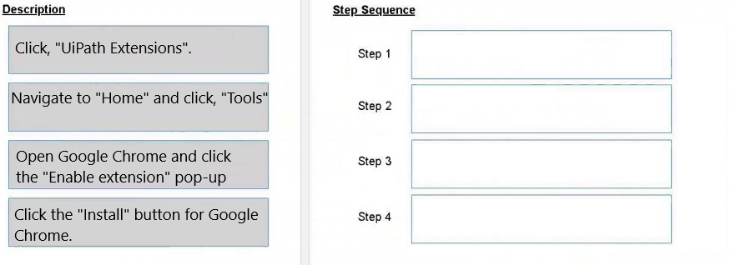

**Answer:-** 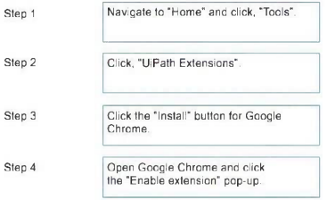

**Question #3**

What are the three source control plug ins found in the backstage view of UiPath Studio in Home - Tools - Plugins?

A. GIT, SVN, Mercurial.

**B. GIT, SVN, TFS.**

C. GIT, CVS, TFS

D. GIT, CVS, Bitbucket.

**Question #4**

A developer utilized the Add Data Row activity to insert a row into a data table called "dt\_Reports". However, during runtime, UiPath Studio encounters an exception, "Add Data Row: Object reference not set to an instance of an object." because the data table has not been initialized.  
To rectify this issue, what should the developer include in an Assign before the Add Data Row activity?

A. Assign New System.Data.DataTable = dt\_Reports.

B. Assign dt\_Reports = New System.Data.DataRow.

**C. Assign dt\_Reports = New System.Data.DataTable.**

D. Assign dt\_Reports = New List(Of DataRow).

**Question #:5**

What is the best method for passing data across activities within workflows?

A. Arguments

B. Namespaces

C. Properties

**D. Variables**

**Question #:6**

What is a correct description of a dictionary?

**A. Dictionaries are collections of key, value pairs, in which the keys are unique.**

B. Dictionaries are collections of item, values, in which no constraints are present over the values of the items.

C. Dictionaries are collections of unique values.

D. Dictionaries are collections of item, values, in which the items and values are unique.

**Question #:7**

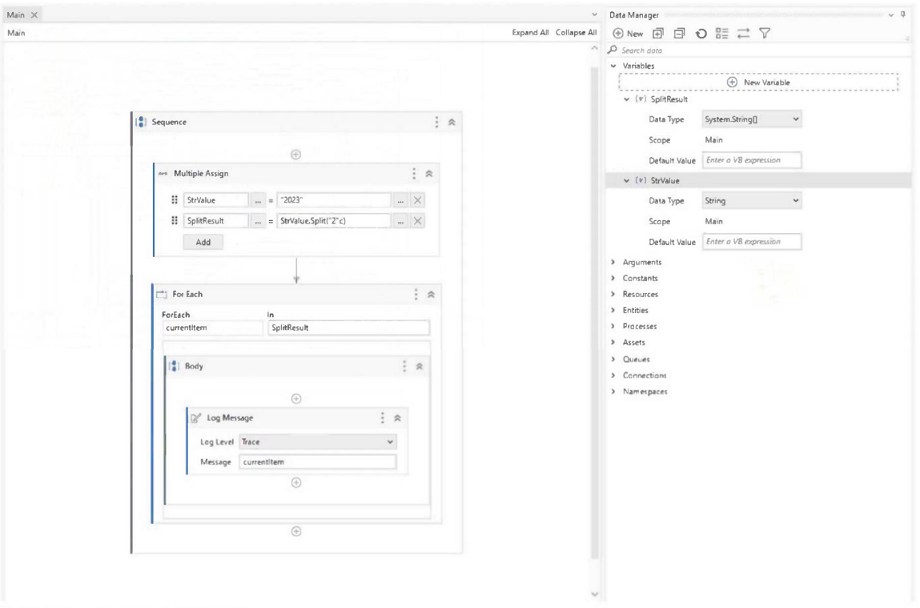

Based on the graphic, what is the output at runtime?

A. <blank>  
0  
0

**B. <blank>  
0  
3**

C. 20  
23

D. 2023

**Question #:8**

How can Folder roles be assigned in an Orchestrator instance where Activate Classic Folders is unchecked under Tenant > Settings > General?

A. From the Roles tab of the Tenant > Manage Access page.

B. From the Tenant > Settings > General page.

C. From the Assign roles tab of the Tenant > Manage Access page Most Voted

**D. From the Folders page or from the folder's Settings page**

**Question #:9**

Considering the following sequence of activities, where should the delay activity be added in order to display the message box every 25 seconds? 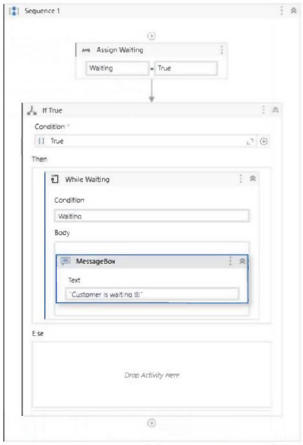

**A. In the While activity**

B. In the If activity

C. Below the While activity

D. In the If activity inside the Else section

**Question #: 10**

Which of the following statements correctly describes the primary purpose of the Use Excel File activity?

A. To create a new Microsoft Excel file with a specified name and location.

B. To convert an existing Microsoft Excel file to a different file format, such as CSV or PDF.

**C. To establish the scope for Excel automation and specify the target Excel file for subsequent activities**.

D. To establish a connection to a Microsoft Excel file and perform complex calculations and data manipulation directly using Studio.

**Question #: 11**

Which is the valid syntax for checking if the StrVar variable of type String includes the word "robot"?

StrVar. Equalsf("robot")

B. "robot".Substring(StrVar)

**C. StrVar.Contains("robot")**

D. StrVar.Substring("robot")

**Question #: 12**

DRAG DROP -  
A developer wants to capture a screenshot of the machine's state during robot execution and send the screenshot in an email. What are the appropriate steps to accomplish this task in the correct order?  
Instructions: Drag the Description found on the left and drop it on the correct Step Sequence found on the right. 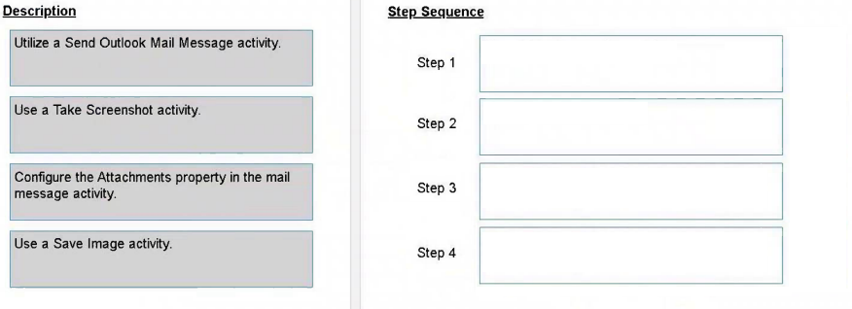

**Answer:- step 4 and 3 change**

**Question #: 13**

Which of the following statements is true about Global Variables?

A. Global Variables store data in a location which can be accessed by all parts of the automation project.

B. Global Variables can be created from the Variables panel.

**C. Global Variables can be created from the Data Manager panel and from the Variables panel.**

D. Global Variables can only have two types: Text and Number.

**Question #: 14**

Which of the following best describes the primary role of UiPath Orchestrator in the ecosystem?

A. Creating, designing, and testing automation workflows.

B. Providing a user-friendly interface for executing automation projects.

**C. Centralized deployment, management, and monitoring of UiPath Robots and processes.**

D. Running and managing attended automation processes on the user's machine.

**Question #: 15**

What is the expected behavior when the execution of a process is started from UiPath Studio in Debug mode and the developer has enabled a breakpoint on a Type Into activity?

A. The execution will pause for 5 seconds when it encounters the breakpoint.

B. The execution will not take the breakpoint into consideration when it encounters the Type activity.

**C. The execution will pause when it encounters the breakpoint until the user clicks the Continue button.**

D. The execution will throw an exception when it encounters the breakpoint.

**Question #: 16**

What component of the UiPath Ecosystem allows a user to post questions or answers on RPA topics?

A. UiPath Marketplace

B. UiPath Studio

C. UiPath Community

**D. UiPath Forum**

**Question #: 17**

Which property of the Check App State activity in UiPath is used to define the maximum wait time for the application state to change?

A. RetryInterval

B. Delay

**C. Timeout**

D. WaitTime

**Question #: 18**

What is true about the behavior of the Read Range Workbook activity?

A. It works with .xlm and .xlsx files, and Excel must be installed on the system.

B. It works only with .xlsm files and Excel must be installed on the system.

C. It works only with .xls files and Excel does not need to be installed on the system.

**D. It works with .xls and .xlsx files and Excel does not need to be installed on the system.**

**Question #: 19**

Which activity or activities should be used to add a suffix to all the file names from a specific folder, considering that the files are present on the local machine?

A. Rename All Files in Folder.

B. For Each File in Folder and Rename Folder.

**C. For Each File in Folder and Rename File.**

D. Rename All Files.

**Question #: 20**

Which of the following actions can be performed from the Tenant context in UiPath Orchestrator?

A. Manage Assets and Storage Buckets for a specific folder.

**B. Manage tenant-level entities, licenses, and settings.**

C. Assign Folder roles and Mixed roles from the Folders page or from the folder’s Settings page.

D. Access Test Sets, Test Cases, and Test Executions tabs for specific folders.

**Question #: 21**

Which activity in UiPath Studio's Properties panel does not require the user to input email credentials?

A. Get IMAP Mail Messages

**B. Get Outlook Mail Messages**

C. Get Exchange Mail Messages

D. Get POP3 Mail Messages

**Question #: 22**

In a UiPath Studio project, what is the broadest scope a variable can have?

A. Within the activity in which it is defined.

B. Within the surrounding "Do" or "Body" sequence

**C. Global, available in the entire project. Most Voted**

D. Outermost container in the current xaml project file.

**Question #: 23**

What happens when there is a breakpoint on an activity and the project is started in Run mode?

A. The project pauses for 5 seconds when it reaches the activity.

B. The project pauses at the activity until the Continue button is clicked.

**C. The project is executed without pausing at the activity.**

D. The project throws an error when it reaches the activity.

**Question #: 24**

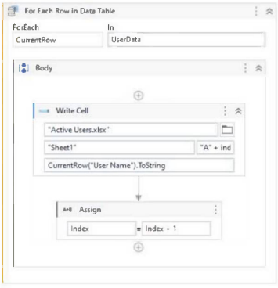

The Write Cell activity has the following properties:

What is the behavior of the sequence once executed?

A. It writes the values in the same row in the "Active Users.xlsx" Excel file.

B. It writes the values in the same row in the UserName data table

C. It writes the values in subsequent rows in the UserName data table.

**D. It writes the values in subsequent rows in the "Active Users.xlsx" Excel file.**

**Question #: 25**

A developer is troubleshooting a workflow that enters a Suspended mode when encountering a breakpoint. To inspect the subsequent activities individually by pausing after each one, which operation must be employed from the Debug section of the UiPath Studio’s toolbar?

A. Slow Step

B. Step Out

C. Break

**D. Step Into**

**Question #: 26**

Which Studio workflow type is best-suited for a simple and linear process?

A. State Machine

B. Global Exception Handler

C. Flowchart

**D. Sequence**

**Question #: 27**

Which of the following statements is true about Global Variables?

**A. Global Variables values can be modified during the automation execution.**

B. Global Variables can be created from the Data Manager panel and from the Variables panel.

C. Global Variables can be accessed only from the Main workflow.

D. Global Variables have a Direction properly (In/Out).

**Question #: 28**

What is one of the main purposes of connecting Robots to Orchestrator?

A. To provide an alternative development environment to Studio.

B. To prevent Robots from operating on unsupported applications.

C. To enable Robots to communicate with other third-party systems.

**D. To manage and monitor Robot deployments and executions centrally.**

**Question #: 29**

A developer executes the following workflow in Debug mode with "Continue on Exception" enabled.

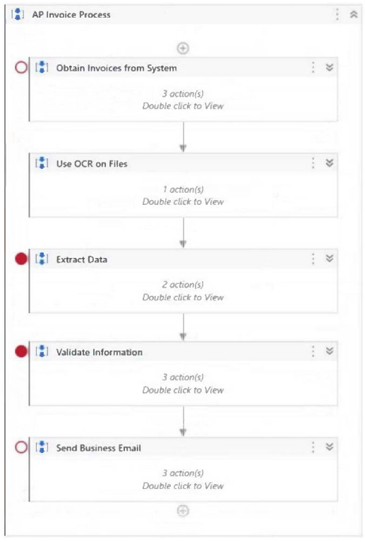

How many times will the workflow pause the execution?

A. 0

B. 1

**C. 2**

D. 3

**Question #: 30**

Which output method should be used to extract hidden text from a PDF file?

**A. FullTexI only.**

B. Native only.

C. OCR.

D. FullText and Native

| Capability Method | Speed | Accuracy | Background Execution | Extract Text Position | Extract Hidden Text | Support for Citrix |
| --- | --- | --- | --- | --- | --- | --- |
| **FullText** | 10/10 | 100% | Yes | no | yes | no |
| **Native** | 8/10 | 100% | No | yes | no | no |
| **OCR** | 3/10 | 98% | No | yes | no | yes |

**Question #: 31**

Which option best describes a process that is considered ZERO-TOUCH AUTOMATION?

A. Processes that are rather digital and can be automated, but use some technologies that are complex (such as OCR) or require advanced programming skills.

**B. Processes that are digital and involve a highly static system and process environment, so that they can be easily broken into instructions and simple triggers can be defined.**

C. Processes where change is frequent, the system environment is volatile, and multiple manual (even non-digital) actions are required.

D. Processes that can be broken down into steps that can be clearly automated, and steps that need to stay manual (such as validations or usage of physical security tokens).

[**Zero-touch automation aims to automate tasks and processes with minimal to no manual intervention, relying on predefined rules and a stable environment**](https://www.getmagical.com/blog/what-is-zero-touch-automation)

**Question #: 32**

A developer extracts data from "Sheet1" of the "Test.xlsx" file that contains 10,000 rows of data using the activity shown below:

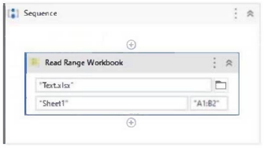

In addition, the developer configured the following properties of the Workbook Read Range activity:

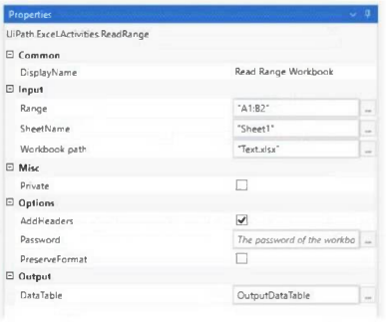

Based on the exhibits, what is the output of the expression, OutputDataTable.Rows.Count and what values will be contained in the OutputDataTable?

A. **OutputDataTable Rows Count = 1 Contains the values of cells "A2 " and "B2"**

B. OutputDataTable Rows Count = 1 Contains the values of cells "AT and " B1"

C. OutputDataTable Rows Count = 2 Contains the values of cells "A2" and " B2"

D. OutputDataTable Rows Count = 10.000 Contains the values of cells "A2" and "B2"

**Question #: 33**

During which stage does an automation developer have the greatest contribution and responsibility?

A. In the Solution Design, Development and Unit Testing, and Deployment and Hypercare stages.

B. In the Process Analysis, Solution Design, and Development and Unit Testing stages.

**C. In the Development and Unit Testing, Integration and UAT, and Deployment and Hypercare stages.**

D. In the Discovery and Kickoff, Development and Unit Testing, and Deployment and Hypercare stages.

**Question #: 34**

Following best practices, which activity is recommended for a developer to generate separate sets of actions for each vendor when developing a process that performs background verification for documents from 10 distinct vendors, each with varying document formats and requiring unique processing?

A. Flow Decision

**B. Flow Switch**

C. For Each

D. Do While

**Question #: 35**

Which panel in UiPath Studio can be used to update the scope of a variable?

A. Data Manager Most Voted

B. Project

C. Locals

**D. Variables**

**Question #: 36**

What happens if a process is started from an on-premise UiPath Orchestrator?

A**. The process starts running on all machines that are provisioned in Orchestrator and were selected for the job.**

B. The process starts running on a different machine as the Orchestrator.

C. The process starts running on the same machine as the Orchestrator.

D. The process starts running on all machines that are provisioned in Orchestrator no matter if they are selected for the job or not.

**Question #: 37**

Who is responsible for devising a strategy to prioritize processes during the Business Case and Technical Validation phase?

A. Project manager

B. Solution architect

C. Automation developer

**D. Business analyst**

**Question #: 38**

Given a variable of Object type that is assigned a Boolean value, what is the expected output when converting the variable to a string using the ToString method?

A. "T" or "F"

B. "t" or "f"

**C. "True" or "False"**

D. "1" or "0"

**Question #: 39**

What are the steps to start building a custom connector using the Connector Builder for Integration Service?

A. Open Automation Cloud, go to Orchestrator, on the Connectors tab. select Add a new Connector, choose to start from an API definition or choose OAuth 2.0 authentication method.

**B. Open Automation Cloud, go to Integration Service, on the Connectors tab, select Add a new Connector, choose to start from an API definition or from a blank connector.**

C. Open UiPath Studio, create a new process, on the Connectors tab, select Add a new Connector, choose to start from an API definition or from a blank connector

D. Open Automation Cloud, go to Orchestrator, on the Connections tab, select Add a new Connection, choose to start from an API definition or from a blank connector

**Question #: 40**

What is the default behavior when publishing files in UiPath Studio regarding the project folder?

A. By default, all files in the project folder, including lest cases, are published as separate packages.

**B. By default, all files in the project folder are published except for test cases.**

C. By default, only selected files in the project folder are published.

D. By default, all files in the project folder are published, including test cases.

**Question #: 41**

Which activity can the developer use to iterate through a list, process each element individually, and utilize the Break activity to stop the iteration if a certain condition is not met?

**A.**Switch

**B.**If

**C.**Assign

**D. For Each**

**Question #: 42**

In the UiPath Implementation Methodology, which phase involves building the SDD (Solution Design Document)?

**A.**Kick-off phase

**B.**User Acceptance Testing phase

**C.**Process Design phase

**D. Solution Design phase**

**Question #: 43**

What activity from the Microsoft 365 package should be used to share a Sharepoint file URL with specific permissions to a specific user?

**A.**Get File/Folder

**B.**Upload File

**C. Share File/Folder**

**D.**Move File/Folder

**Question #: 44**

A developer is working on a project that uses GIT for source control. A fellow team member seeks to compare two versions of a specific workflow within the project.  
Which option in UiPath Studio offers this functionality?

**A. Show History**

**B.**Checkout Branch

**C.**Push

**D.**Pull (rebase)

**Question #: 45**

Which of the following statements accurately describes the role of the For Each Excel Row activity?

**A.**It reads and stores the content of an entire worksheet in a DataTable variable.

**B.**It writes specified data to a range of cells in an Excel file.

**C. It iterates through all the rows in a specified range, allowing to perform actions with each row.**

**D.**It filters an Excel table based on specific criteria and creates a new table with the filtered data.

**Question #: 46**

While working on a project that utilizes Object Repository, you have one linked UI Element that is used across multiple activities. What needs to happen to edit a selector for only one activity without modifying it in Object Repository?

**A.**Edit target.

**B.**Show in Object Repository.

**C.**Indicate target on screen.

**D. Unlink from Object Repository.**

**Question #: 47**

What is the purpose of using project templates in UiPath Studio?

**A. To quickly start a new project with pre-built components and structure based on best practices**.

**B.**To manage project dependencies and versioning.

**C.**To create a webpage layout with pre-built UI elements.

**D.**To group reusable custom components across different automation projects.

**Question #: 48**

Which of the following statements is correct about arguments?

**A.**Argument names are automatically updated in the activities inside the current workflow when the name of the argument is changed in the Data Manager

**B.**Only String argument names are automatically updated in the activities inside the current workflow when the name of the argument is changed in the data manager.

**C.**Argument names cannot be changed after an argument was created, if you need to rename an argument you should re-create the argument.

**D. Argument names are not automatically updated in the activities inside the current workflow, if you rename an argument you need to manually change the name inside the activities.**

**Question #: 49**

Which of the following is a main feature of the Manage Packages feature in UiPath Studio?

**A. Installing, uninstalling, and updating activity packages in a project.**

**B.**Managing package dependencies exclusively for attended automation projects.

**C.**Automatically updating at packages in a project to their latest versions.

**D.**Disabling previously installed packages without uninstalling them.

**Question #: 50**

Which of the following statements is true about Global Constants?

**A. Global Constants store data in a location which can be accessed by all parts of the automation project**

**B.**Global Constants properties car be modified Curing the automation execution

**C.**Global Constants can be created from the Data Manager panel and from the Variables panel

**D.**Global Constants have a Scope property

**Question #: 51**

An attended automation user wants to run two background processes in UiPath Assistant: "UpdateTimecards Process" and "GetPTODays Process".  
What is a characteristic of running these processes?

**A. Update Timecards Process and GetPTODays Process can be run concurrently in the background.**

**B.**UpdateTimecards Process and GetPTODays Process can be run concurrently only if started from Orchestrator.

**C.**An exception is thrown if the processes are executed concurrently.

**D.**UpdateTimecards Process and GetPTODays Process can only be run sequentially.

**Question #: 52**

In a project involving an Orchestrator queue, a developer needs to extract the two values from the ItemInformation fields of each QueueItem object.  
How can those fields be extracted from the variable?

**A.**Use a Get Transaction Item activity for each ItemInformation field.

**B.**Use a Get Asset activity for each ItemInformation field.

**C. Use the SpecificContent property and supply the name of the field as the Key.**

**D.**Assign output variables for each field in the Add Queue Item activity.

**Question #: 53**

A developer is designing a project where emails containing different employee IDs are sent to the process owner for each completed transaction. The process owner changes only once per year.  
Which values should be designated as Orchestrator Queues versus Assets?

**A.**Process Owner Email as a field in the Queue Item and Employee ID as an Orchestrator Asset.

**B. Process Owner Email as an Orchestrator Asset and Employee ID as a field in the Queue Item.**

**C.**Process Owner Email as an Orchestrator Asset and Employee ID as an Orchestrator Asset.

**D.**Process Owner Email as a field in the Queue Item and Employee ID as a field in the Queue Item.

**Question #: 54**

**Question #: 100**

**Question #: 100**

**Question #: 100**

**Question #: 100**

**Question #: 100**

**Question #: 100**

**Question #: 100**

**Question #: 100**

What is the accepted data type tor the Selector property of an activity?

A. System.String

B. System.Xml.XmlElement

C. System.Security.SecureString

D. UiPath.Core.Selector

**Question #: 101**

A developer has created a data table. "dt\_Users", as shown in the following exhibit:

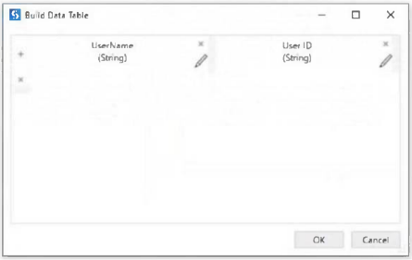

After scraping the data from a web application the developer wants to assign each row in the "dt\_Users" variable to a Dictionary<string, string> variable, "DictUsers". In addition, the developer wants to assign the user IDs to the keys and the usernames to the values inside a For Each Row activity. 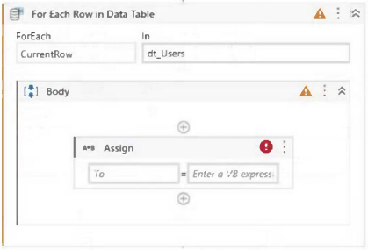

How should the Assign activity be configured?

**A. DictUsers(CurrentRow(1).ToString) = CurrentRow(0).ToString**

B. CurrentRow(1).ToString = DictUsers(CurrentRow(0).ToString)

C. DictUsers(CurrentRow(0)) = DictUsers(CurrentRow(1).ToString)

D. DictUsers(CunrentRow(1).ToString) = DictUsers(CurrentRow(0).ToString)

The correct configuration for the Assign activity is **A. DictUsers(CurrentRow(1).ToString) = CurrentRow(0).ToString**.

Here’s why:

* **CurrentRow(1).ToString** accesses the user ID in the current row, which will be used as the key in the dictionary.
* **CurrentRow(0).ToString** accesses the username in the current row, which will be used as the value in the dictionary.

**Question #: 109**

Given the following workflow image:

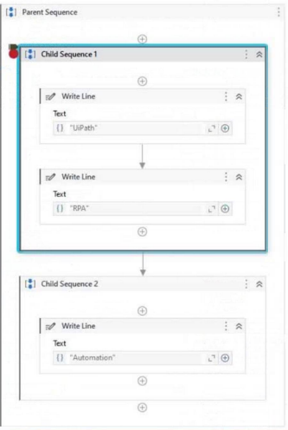

After the Step Out is clicked on the Debug ribbon tab of UiPath studio, what will be displayed on the Output panel?

A. UiPath RPA

B. UiPath

**C. UiPath RPA Automation**

D. RPA

**Question #: 165**

“Process A” is scheduled to run at 2:00 PM using a time trigger with the Schedule ending of job execution feature configured to stop the job after 20 minutes. Assuming that the robots are busy and “Process A” is queued until 2:05 PM, at what time will “Process A” be stopped?

**A. 2:20 PM**

B. 2:25 PM

C. 2:05 PM

D. 2:28 PM

**Question #: 165**

While troubleshooting a process developed using the Robotic Enterprise (RE) Framework, you have placed a breakpoint at the "Invoke InitAllSettings" workflow activity.

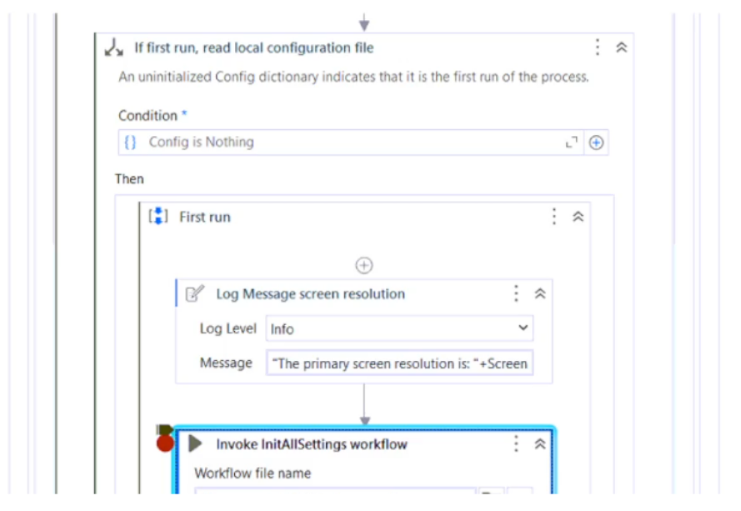

Given the current state of the Executor, what will occur when you click on the Step Over button?

* A. Executor directs to the "If in\_OrchestratorQ..." activity
* B. Executor directs to the "First Run" sequence
* C. Executor directs to the first InitAllSettings workflow activity
* D. Executor directs to the first activity outside "If first run, read local configuration"

**Ans :A**

**Question #: 176**

What are the five severity levels of Orchestrator alerts?

* A. Info, Success, Warning, Error, Critical.
* B. Info, Success, Warn, Error, Fatal.
* C. Information, Complete, Warning, Error, Failure.
* D. Info, Completed, Warning, Error, Fatal.

**B is correct**

Alerts inform you about the component status in the automation flow. The information is split into different types of severity, helping you track an execution or identify the faulty ones.

There are five severity levels, to indicate the state of your process execution:

* Info

- notifies you about low importance events, that do not interrupt the process execution.

* Success

- notifies you about a successful status.

* Warn

- notifies you about possible risky events that may interrupt your process execution, but any interruption can be recovered.

* Error

- notifies you about imminent risky events that prevent the process from executing successfully.

* Fatal

- notifies you about events that force-stops the process execution.

* Various

- the triggering event may have distinct severity levels.

1: In the context of UiPath Orchestrator, what is the primary purpose of the Monitoring feature?

**Options:**

A.

Handling version control and collaboration among team members.

B.

**Real-time tracking of Robots, Machines, Queues, and Jobs.**

C.

Facilitating the design and deployment of automation workflows.

D.

Consolidating event logs and records related to executed tasks and runtime anomalies.

2: What is the correct execution order of the State activity sections?

instructions: Drag the Description found on the "Left" and drop on the correct Execution Order found on the "Right"

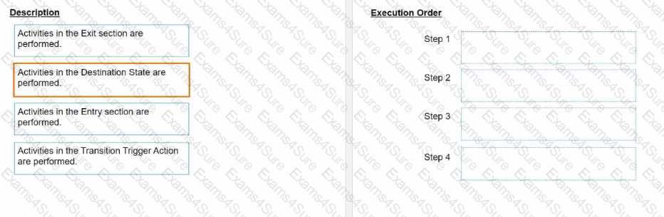

**Options:**

 Hide Solution  Discussion **0**

**Answer:**

Answer: 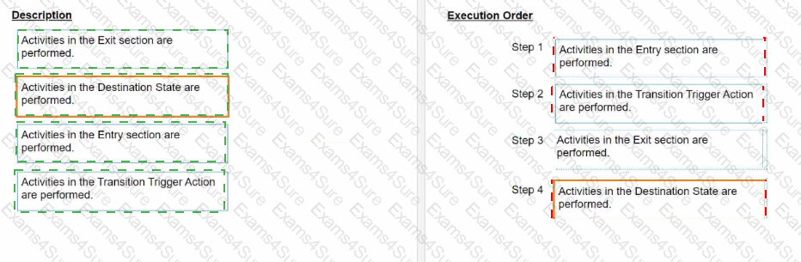

**Question # 4**

What is the default polling interval set for an event trigger?

**Options:**

A. 1 minute

**B.  5 minutes**

C.  10 minutes

D.  15 minutes

**Question # 5**

A developer has created a variable of type List of Strings named "Users\_List", and initialized it with an empty list: "Users\_List = new List(Of String)".

What is printed in the log message after the following Invoke Code is executed?

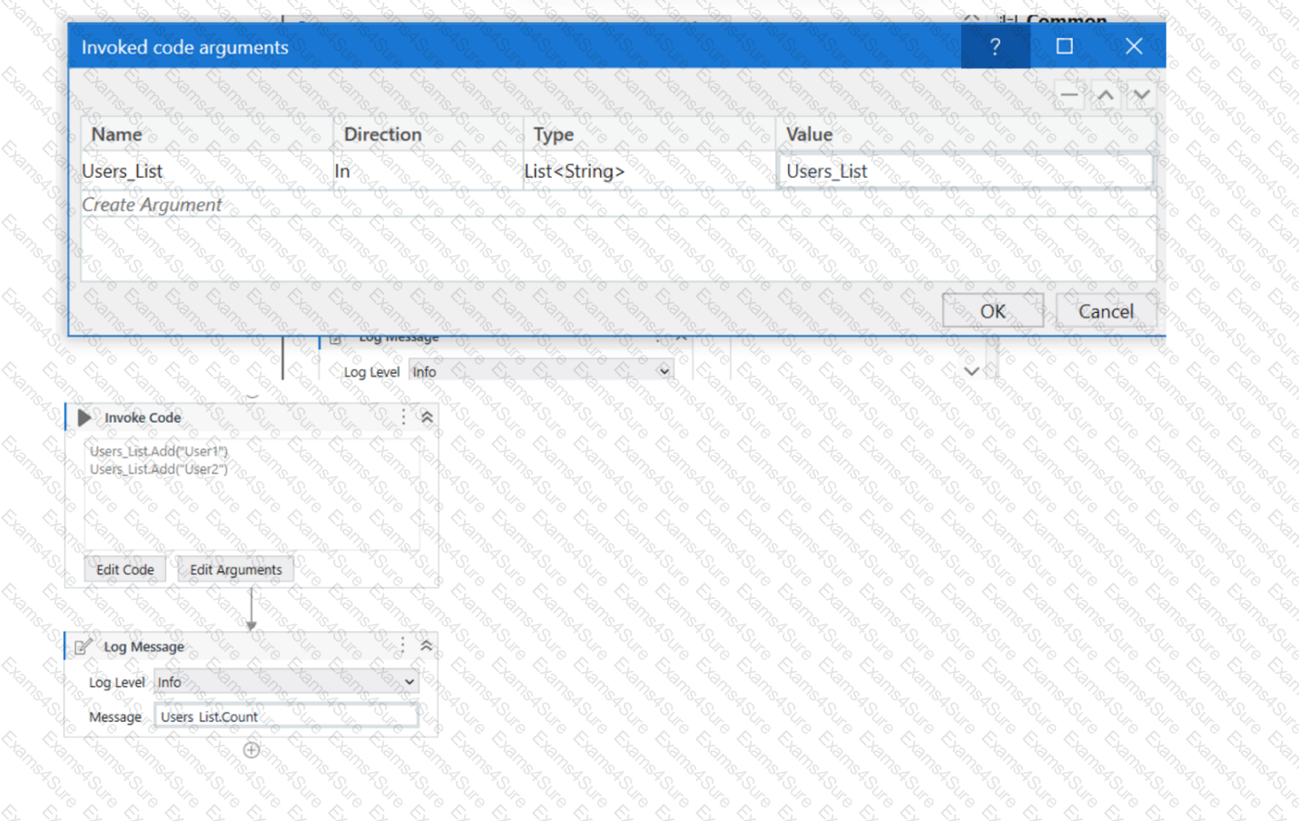

**Options:**

A.  0

**B.  2**

C.  Object reference not set to an instance exception is thrown

D.  System Argument Exception is thrown

**Question # 6**

When a developer runs a process using the REFramework, with the process utilizing Orchestrator queues and a queue already created with the Name provided and the Auto Retry function disabled, which states will be executed without errors?

**Options:**

**A.  Initialization -> Get Transaction Data -> Process Transaction -> End Process**

B.  Initialization -> Get Transaction Data -> End Process

C.  Initialization -> Process Transaction -> End Process

D.  Initialization -> End Process

**Question # 7**

In a UiPath project that uses State Machines, under what circumstances should the Final State activity be used in the project?

**Options:**

A.  When an intermediary state has multiple possible transitions.

B.  When a particular state contains complex conditional logic.

C.  When initiating the first state of a state machine.

**D.  When marking the successful completion or termination of a state machine's execution.**

**Question # 8**

In the context of a linear proces

s, implemented with REFramework, how many times will the process enter the Get Transaction Data state?

**Options:**

A.  1 lime

**B.  2 times.**

C.  The process will not enter the Get Transaction Data state because a linear process is not transactional.

D.  Until there are no more queue items left unprocessed in Orchestrator

0-----------------------Pass 4 suceess

1. A developer configured the properties for a Click activity on an element inside a web page as shown in the following exhibit.

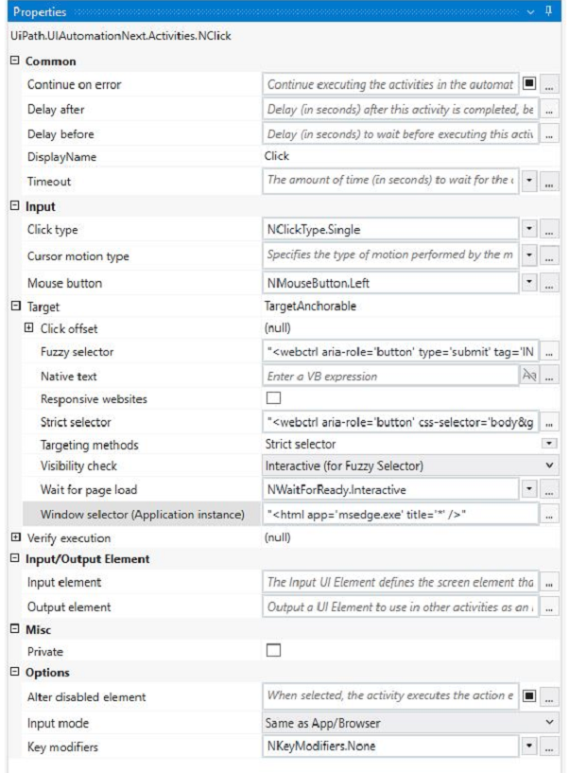

An animation on the web page never completely loads but the element indicated in the Click activity does load within the specified timeout duration. What occurs when this Click activity executes?

AElement is clicked once the element is fully loaded.

**B**Timeout error occurs without clicking on the element.

**C**Waits 10 seconds before clicking on the element.

**D**Continues to the next activity after 30 seconds without clicking on the element.

**Suggested Answer:** *A*

[The Click activity is used to simulate a mouse click on a specified UI element, such as a button or a link1.It has several properties that can be configured to customize its behavior, such as the input method, the click type, the timeout, and the wait for ready1.](https://docs.uipath.com/activities/other/latest/ui-automation/click)

[The input method determines how the click is performed. It can be Default, Simulate, or Window Messages. The Default method uses the hardware driver to simulate the click, and it requires the target element to be visible and in focus.The Simulate and Window Messages methods use the technology of the target application to inject the click, and they can work in the background, even if the target element is hidden or minimized2.](https://forum.uipath.com/t/how-to-effectively-use-simulate-click-and-simulate-type/366373)

[The click type determines which mouse button is used for the click. It can be Single, Double, Down, or Up. The Single and Double types perform a single or double click using the left mouse button.The Down and Up types perform a press or release action using any mouse button1.](https://docs.uipath.com/activities/other/latest/ui-automation/click)

[The timeout determines how long the activity waits for the target element to appear before throwing an error. It is measured in milliseconds, and it has a default value of 30000 (30 seconds).If the timeout is exceeded, the activity fails with a TimeoutException1.](https://docs.uipath.com/activities/other/latest/ui-automation/click)

[The wait for ready determines when the activity executes. It can be None, Interactive, or Complete. The None option executes the activity immediately. The Interactive option executes the activity after the target element is loaded.The Complete option executes the activity after the target application is loaded1.](https://docs.uipath.com/activities/other/latest/ui-automation/click)

In your case, you have configured the properties for the Click activity as follows:

Input method: Simulate

Click type: Single

Timeout: 30000

Wait for ready: Complete

This means that the Click activity will use the Simulate method to perform a single click on the target element in the background, after waiting for 30 seconds or until the target application is fully loaded, whichever comes first.

Since you have mentioned that an animation on the web page never completely loads but the element indicated in the Click activity does load within the specified timeout duration, what occurs when this Click activity executes is:

Element is clicked once the element is fully loaded.

This is because the Simulate method can work in the background, even if the web page is hidden or minimized, and it does not depend on the animation to complete. The Complete option for wait for ready ensures that the Click activity waits until the target element is loaded before clicking on it. The timeout value of 30000 does not affect this scenario, because it is not exceeded.

Therefore, option A is correct.

[Click - UiPath Documentation Portal.](https://docs.uipath.com/activities/other/latest/ui-automation/click)

[What are different Input methods in UiPath - UiPath Community Forum.](https://forum.uipath.com/t/how-to-effectively-use-simulate-click-and-simulate-type/366373)

2. Following UiPath best practices, which project structure is best-suited for complex processes in UiPath Studio?

**A**State Machine  
**B**Global Exception Handler  
**C**Sequence  
**D**Flowchart

**Suggested Answer:** *A*

[According to the UiPath documentation and best practices, the State Machine project structure is best-suited for complex processes that involve multiple states and transitions between them12. A State Machine workflow can model the behavior of a system in terms of states, such as ''Init'', ''Get Transaction Data'', ''Process Transaction'', and ''End Process'', and transitions, such as ''Success'', ''Business Rule Exception'', or ''System Error''.A State Machine workflow can also have entry and exit actions for each state, which are activities that execute when the system enters or exits the state, respectively1.](https://docs.uipath.com/studio/standalone/2021.10/user-guide/design-best-practices)

[A State Machine project structure has several advantages over other project structures, such as Sequence, Flowchart, or Global Exception Handler, for complex processes2:](https://www.uipath.com/learning/video-tutorials/project-organization)

[It can handle complex logic and branching conditions more easily and clearly than a Sequence or a Flowchart, which can become cluttered and hard to maintain for large processes2.](https://www.uipath.com/learning/video-tutorials/project-organization)

[It can handle exceptions and errors more efficiently and consistently than a Global Exception Handler, which is a separate workflow that handles all exceptions in a project.A State Machine can have dedicated states and transitions for handling different types of exceptions, such as business rule exceptions or system errors, and can also use retry mechanisms or recovery actions2.](https://docs.uipath.com/studio/standalone/2021.10/user-guide/design-best-practices)

[It can improve the readability, modularity, and reusability of the workflows, by breaking down the process into smaller and coherent states that can be invoked from the main workflow.This also facilitates collaboration and testing among developers2.](https://docs.uipath.com/studio/standalone/2021.10/user-guide/design-best-practices)

Therefore, a State Machine project structure is best-suited for complex processes that involve multiple states and transitions between them.

[State Machine Workflows - Campus Management Corp..](https://docs.uipath.com/studio/standalone/2021.10/user-guide/design-best-practices)

[UiPath Best Practices - Studio - UiPath Community Forum.](https://www.uipath.com/learning/video-tutorials/project-organization)

Question #: 3  
Topic #: 1

[**[All UiPath-ADAv1 Questions]**](https://www.pass4success.com/uipath/exam/uipath-adav1)

A developer intends to enter text into an input field using a combination of a string and a hotkey. The input action should take place within a hidden or minimized window.

Which input method(s) can be used individually for the Type Into activity?

**A**Simulate only.

**B**Simulate and Window Messages.

**C**Same as App/Browser and Simulate.

**D**Window Messages only.

[Hide Answer](https://www.pass4success.com/uipath/discussions/exam-uipath-adav1-topic-1-question-3-discussion)

**Suggested Answer:** *B*

[The Type Into activity is used to enter text in a specified UI element, such as a text box.It has three input methods that can be selected from the properties panel: Default, Simulate, and Window Messages1.Each input method has different advantages and limitations, depending on the target application and the automation scenario2.](https://docs.uipath.com/activities/other/latest/ui-automation/n-type-into)

The Default input method uses the hardware driver to simulate the keystrokes, as if a human user is typing on the keyboard. It is the most reliable and compatible input method, but it requires the target application to be in focus and visible on the screen. It also supports sending special keys, such as Tab or Enter, using brackets [k(enter)] or [k(tab)].

The Simulate input method uses the technology of the target application to directly inject the text into the UI element. It does not rely on the hardware driver, so it can work in the background, even if the target application is hidden or minimized. It also supports sending special keys using brackets [k(enter)] or [k(tab)]. However, it may not be compatible with some applications or UI elements that do not support this method.

The Window Messages input method uses the Windows API to send messages directly to the target application. It can also work in the background, even if the target application is hidden or minimized. It does not support sending special keys using brackets [k(enter)] or [k(tab)], but it can send them using modifiers such as {ENTER} or {TAB}. However, it may not be compatible with some applications or UI elements that do not accept window messages.

Therefore, if a developer intends to enter text into an input field using a combination of a string and a hotkey, and the input action should take place within a hidden or minimized window, they can use either the Simulate or the Window Messages input method individually for the Type Into activity. They cannot use the Default input method, because it requires the target application to be in focus and visible on the screen. They also cannot use the Same as App/Browser input method, because it is not an option for the Type Into activity.

[Type Into - UiPath Documentation Portal.](https://docs.uipath.com/activities/other/latest/ui-automation/n-type-into)

[What are different Input methods in UiPath - UiPath Community Forum.](https://forum.uipath.com/t/how-to-take-input-from-user-and-pass-it-into-some-type-into-activity-in-later-flow/100772)

Question #: 4  
Topic #: 1

[**[All UiPath-ADAv1 Questions]**](https://www.pass4success.com/uipath/exam/uipath-adav1)

How does UiPath Integration Service benefit automation developers?

**A**By standardizing authorization and authentication, managing API connections, and enabling faster integration into SaaS platforms.

**B**By offering a comprehensive, unified platform dedicated solely to UI automation, enabling seamless integration with third-party applications.

**C**By enabling developers to create custom UI elements for applications without using APIs.

**D**By substituting the requirement for API automation with UI automation capabilities, delivering a more manageable and user-friendly approach, allowing users to streamline their processes efficiently and effectively facilitating a more rapid integration process.

[Hide Answer](https://www.pass4success.com/uipath/discussions/exam-uipath-adav1-topic-1-question-4-discussion)

**Suggested Answer:** *A*

[The UiPath Integration Service is a new feature that seamlessly combines world-class UI and API automation, allowing both capabilities to be centrally accessed within the same integration design environment12.This empowers developers to flexibly capture all their automation opportunities, even allowing them to deploy both types of integrations within a single automation12.The UiPath Integration Service also provides the following benefits for automation developers12:](https://www.uipath.com/resources/automation-demo/introducing-integration-service)

[By standardizing authorization and authentication, it simplifies the security protocols for connecting to different systems and applications, such as Salesforce, SAP, or Google G Suite2.](https://www.uipath.com/blog/product-and-updates/introducing-uipath-integration-service)

[By managing API connections, it enables developers to create, modify, reuse, and share connections to multiple systems using pre-built connectors or custom connectors2.](https://www.uipath.com/blog/product-and-updates/introducing-uipath-integration-service)

[By enabling faster integration into SaaS platforms, it allows developers to leverage server-side event triggers to start automations based on data updates, insertions, or deletions in external applications2.](https://www.uipath.com/blog/product-and-updates/introducing-uipath-integration-service)

[Introducing UiPath Integration Service | UiPath.](https://www.uipath.com/resources/automation-demo/introducing-integration-service)

[New UiPath Integration Service | UiPath.](https://www.uipath.com/blog/product-and-updates/introducing-uipath-integration-service)

Question #: 5  
Topic #: 1

[**[All UiPath-ADAv1 Questions]**](https://www.pass4success.com/uipath/exam/uipath-adav1)

Which of the following statements accurately describes the primary components of a State Machine in a workflow?

**A**A State Machine consists of four primary components: States, Triggers, Transitions, and Actions.

**B**A State Machine is composed of States, Triggers, and Loops.

**C**A State Machine comprises three main components: Sequences, Flowcharts, and Input/Output Arguments.

**D**A State Machine is made up of States, Transitions, Entry Actions, and Exit Actions.

[Hide Answer](https://www.pass4success.com/uipath/discussions/exam-uipath-adav1-topic-1-question-5-discussion)

**Suggested Answer:** *D*

Question #: 6  
Topic #: 1

[**[All UiPath-ADAv1 Questions]**](https://www.pass4success.com/uipath/exam/uipath-adav1)

What actions must be manually selected in the App/Web Recorder before recording a step?

**A**Copy text using the Get Text activity.  
Hover over an element using the Hover activity.  
Highlight an element using the Highlight activity.

**B**Copy text using the Get Text activity.  
Hover over an element using the Hover activity.  
Click on buttons, links, and other clickable elements such as icons or images.  
Type text in a text area such as a text box.  
Select or clear a check box.

**C**Select or clear a check box.  
Send keyboard shortcuts using your keyboard.  
Select an item from a drop-down.

**D**Click on buttons, links, and other clickable elements such as icons or images.  
Type text in a text area such as a text box.  
Select or clear a check box.  
Send keyboard shortcuts using your keyboard.  
Select an item from a drop-down.

[Hide Answer](https://www.pass4success.com/uipath/discussions/exam-uipath-adav1-topic-1-question-6-discussion)

**Suggested Answer:** *A*

[The App/Web Recorder is a tool that allows you to record your actions on an application or a web browser and generate activities automatically1.The App/Web Recorder has a toolbar that contains different actions that you can select before recording a step2. Some of these actions are:](https://docs.uipath.com/activities/other/latest/user-guide/app-web-recorder)

Click: This action records a click on a button, link, or any other clickable element.

Type: This action records typing text in a text box or any other text area.

Check: This action records selecting or clearing a check box.

Send Hotkey: This action records sending keyboard shortcuts using your keyboard.

Select Item: This action records selecting an item from a drop-down list or any other selector.

[These actions are automatically detected and recorded by the App/Web Recorder when you perform them on the application or web browser3. However, there are some actions that are not automatically detected and recorded by the App/Web Recorder, and you need to manually select them from the toolbar before recording a step. These actions are:](https://docs.uipath.com/studio/v2018.3.0/docs/example-of-automatic-recording-with-web)

Get Text: This action records copying text from a label, paragraph, or any other text element.

Hover: This action records hovering over an element with your mouse cursor.

Highlight: This action records highlighting an element with a colored border.

[These actions are useful for extracting data, triggering events, or identifying elements on the application or web browser4.To use these actions, you need to select them from the toolbar and then indicate the element on the screen that you want to apply them to5.](https://docs-legacy.uipath.com/studio/v2019/docs/example-of-automatic-recording-with-web.html)

Therefore, option A is the correct answer, as it lists the actions that must be manually selected in the App/Web Recorder before recording a step. Option B includes some actions that are automatically detected and recorded by the App/Web Recorder, such as Click and Type. Option C also includes some actions that are automatically detected and recorded by the App/Web Recorder, such as Check and Send Hotkey. Option D includes all the actions that are automatically detected and recorded by the App/Web Recorder.

Question #: 7  
Topic #: 1

[**[All UiPath-ADAv1 Questions]**](https://www.pass4success.com/uipath/exam/uipath-adav1)

What happens to existing project dependencies in UiPath Studio when converting a Windows-Legacy project to Windows?

**A**Project dependencies are updated to the highest available version.

**B**Project dependencies are completely removed.

**C**Project dependencies remain unchanged.

**D**Project dependencies are marked as unresolved.

[Hide Answer](https://www.pass4success.com/uipath/discussions/exam-uipath-adav1-topic-1-question-7-discussion)

**Suggested Answer:** *A*

When converting a Windows-Legacy project to Windows, the project dependencies are automatically updated to the highest available version that is compatible with the Windows target framework. This is done to ensure that the project can use the latest features and improvements of the activities packages, as well as to avoid potential issues or conflicts with the legacy versions. The updated dependencies are reflected in the project.json file and the Manage Packages window of the project. The developer can also manually update the dependencies to a specific version if needed.

References:

[Deprecation of the Windows-Legacy Compatibility - UiPath Studio](https://forum.uipath.com/t/convert-windows-project-to-windows-legacy/389454)

[Convert Windows Project to Windows-Legacy - UiPath Community Forum](https://forum.uipath.com/t/convert-windows-legacy-to-windows/484803)

Question #: 8  
Topic #: 1

[**[All UiPath-ADAv1 Questions]**](https://www.pass4success.com/uipath/exam/uipath-adav1)

Which Control Flow activity is suitable for a developer who needs to assess the value of a counter before executing the loop's body in a workflow?

**A**Do While

**B**Switch

**C**)While

**D**If

[Hide Answer](https://www.pass4success.com/uipath/discussions/exam-uipath-adav1-topic-1-question-8-discussion)

**Suggested Answer:** *C*

The While activity is a Control Flow activity that enables the developer to execute a specified part of the automation while a condition is met. The condition is evaluated before the loop body is executed, which means that the developer can assess the value of a counter or any other variable before performing the actions inside the loop. This type of activity can be useful to iterate through an array, a list, a data table, or any other collection of data, or to repeat an action until a certain value is reached or changed. The While activity can be found in the Activities panel, under Workflow > Control.

References:

[While - UiPath Activities](https://docs.uipath.com/studio/standalone/2023.10/user-guide/control-flow-activities)

[While Activity - UiPath Studio](https://docs.uipath.com/studio/standalone/2023.10/user-guide/about-control-flow)

[UiPath While Loop Tutorial with Examples - RPA Tutorial](https://rpayourway.com/reference-guides/control-flow/)

Question #: 9  
Topic #: 1

[**[All UiPath-ADAv1 Questions]**](https://www.pass4success.com/uipath/exam/uipath-adav1)

What is the main benefit of importing profiling sessions?

**A**Enables the analysis of potential flow issues.

**B**Provides context menu options for profiling actions.

**C**Disables focus on imported profiling sessions.

**D**Disables the analysis of potential flow issues.

[Hide Answer](https://www.pass4success.com/uipath/discussions/exam-uipath-adav1-topic-1-question-9-discussion)

**Suggested Answer:** *A*

The main benefit of importing profiling sessions is that it enables the analysis of potential flow issues in the automation workflows. By importing profiling sessions, the developer can examine previous runs and compare them with the current run. This can help the developer to identify which workflows or activities take longer to execute, which ones consume more resources, and which ones cause errors or exceptions. The developer can also use the Profiler app to visualize the profiling data and drill down into the details of each operation. This way, the developer can optimize the performance and reliability of the automation workflows and improve the user experience.

References:

[Studio - Profile Execution - UiPath Documentation Portal](https://docs.uipath.com/studio/standalone/2023.10/user-guide/profile-execution)

[Process Mining - Application Profiling - UiPath Documentation Portal](https://docs.uipath.com/process-mining/standalone/2021.10/user-guide/application-profiling)

Question #: 10  
Topic #: 1

[**[All UiPath-ADAv1 Questions]**](https://www.pass4success.com/uipath/exam/uipath-adav1)

Which of the following functionalities does UiPath Assistant provide?

**A**Developing automation workflows in UiPath Studio.

**B**Running, managing, and organizing automation workflows on the user's machine.

**C**Scheduling and monitoring robot processes in Orchestrator.

**D**Analyzing processes to determine optimal automation solutions.

[Hide Answer](https://www.pass4success.com/uipath/discussions/exam-uipath-adav1-topic-1-question-10-discussion)

**Suggested Answer:** *B*

UiPath Assistant is a desktop tool that enables users to easily access, manage, and run automation workflows on their machines. It provides the following functionalities:

Viewing all the available automations that the user can run, either from Orchestrator or locally.

Adding automations to the launchpad for quick and easy access.

Creating custom folders and sections to organize the automations according to the user's preferences.

Running automations with a single click or using keyboard shortcuts.

Launching robot-powered apps and managing action center tasks directly from the assistant.

Customizing the assistant's appearance, name, and avatar to suit the user's personality.

Viewing the status and progress of the running automations, as well as the history and logs of the past executions.

Connecting to Orchestrator and synchronizing the automations and settings with the cloud.

Accessing the help and feedback options, as well as the interactive guided tour.

References:

[Software Robot Assistant - Desktop Automation | UiPath](https://www.uipath.com/product/software-robot-assistant)

[Robot - About UiPath Assistant - UiPath Documentation Portal](https://docs.uipath.com/robot/standalone/2023.10/user-guide/about-uipath-assistant)

Question #: 11  
Topic #: 1

[**[All UiPath-ADAv1 Questions]**](https://www.pass4success.com/uipath/exam/uipath-adav1)

What will be the outcome when executing a Try Catch activity with a sequence placed within the Try section and no Catches section present?

**A**In case of an exception, a System Exception will be caught by default.

**B**Due to a validation error, the workflow will not execute.

**C**Process execution will terminate only if the sequence throws an exception.

**D**The sequence will result in a runtime error.

[Hide Answer](https://www.pass4success.com/uipath/discussions/exam-uipath-adav1-topic-1-question-11-discussion)

**Suggested Answer:** *B*

[According to the UiPath documentation, the Try Catch activity requires at least one catch to be added1. If there is no catch defined for the Try Catch activity, the workflow will not pass the validation and will not execute. The validation error message will say: ''Try Catch: At least one catch must be added to the Try Catch activity.'' Therefore, the outcome of executing a Try Catch activity with a sequence placed within the Try section and no Catches section present will be a validation error.References:Activities - Try Catch](https://docs.uipath.com/activities/other/latest/workflow/try-catch)

Question #: 12  
Topic #: 1

[**[All UiPath-ADAv1 Questions]**](https://www.pass4success.com/uipath/exam/uipath-adav1)

Which dependencies are automatically installed when a developer starts a blank process in UiPath Studio?

**A**UiPath.Database.Activities and UiPath.Form.Activities.

**B**UiPath.Python.Activities and UiPath.Word.Activities.

**C**UiPath.System.Activities, UiPath.Excel.Activities, UiPath.Mail.Activities, UiPath.UIAutomation.Activities and UiPath. Testing.Activities.

**D**UiPath.PDF.Activities and UiPath. Terminal.Activities.

[Hide Answer](https://www.pass4success.com/uipath/discussions/exam-uipath-adav1-topic-1-question-12-discussion)

**Suggested Answer:** *C*

[When a developer starts a blank process in UiPath Studio, the following dependencies are automatically installed by default: UiPath.System.Activities, UiPath.Excel.Activities, UiPath.Mail.Activities, UiPath.UIAutomation.Activities and UiPath. Testing.Activities. These dependencies provide the basic activities and packages that are needed for most automation projects, such as working with data types, files, Excel, email, user interface, and testing. The developer can also add or remove other dependencies as needed, depending on the specific requirements of the automation project.References:Creating a Basic Process,Managing Dependencies.](https://docs.uipath.com/studio/standalone/2023.10/user-guide/creating-basic-process)

Question #: 12  
Topic #: 1

[**[All UiPath-ADAv1 Questions]**](https://www.pass4success.com/uipath/exam/uipath-adav1)

Which dependencies are automatically installed when a developer starts a blank process in UiPath Studio?

**A**UiPath.Database.Activities and UiPath.Form.Activities.

**B**UiPath.Python.Activities and UiPath.Word.Activities.

**C**UiPath.System.Activities, UiPath.Excel.Activities, UiPath.Mail.Activities, UiPath.UIAutomation.Activities and UiPath. Testing.Activities.

**D**UiPath.PDF.Activities and UiPath. Terminal.Activities.

[Hide Answer](https://www.pass4success.com/uipath/discussions/exam-uipath-adav1-topic-1-question-12-discussion)

**Suggested Answer:** *C*

[When a developer starts a blank process in UiPath Studio, the following dependencies are automatically installed by default: UiPath.System.Activities, UiPath.Excel.Activities, UiPath.Mail.Activities, UiPath.UIAutomation.Activities and UiPath. Testing.Activities. These dependencies provide the basic activities and packages that are needed for most automation projects, such as working with data types, files, Excel, email, user interface, and testing. The developer can also add or remove other dependencies as needed, depending on the specific requirements of the automation project.References:Creating a Basic Process,Managing Dependencies.](https://docs.uipath.com/studio/standalone/2023.10/user-guide/creating-basic-process)

Question #: 14  
Topic #: 1

[**[All UiPath-ADAv1 Questions]**](https://www.pass4success.com/uipath/exam/uipath-adav1)

A process workflow contains a Try Catch activity that is designed to catch and stop when any unknown System Exceptions occur. What would be the recommended Log Level

for the Log Message contained in the System Exception block?

**A**Info

**B**Warn

**C**Fatal

**D**Error

[Hide Answer](https://www.pass4success.com/uipath/discussions/exam-uipath-adav1-topic-1-question-14-discussion)

**Suggested Answer:** *C*

The recommended Log Level for the Log Message activity that is contained within the System Exception block of a Try Catch activity designed to catch and stop for any unknown System Exceptions is 'Fatal.' This level is used to indicate that a critical error has occurred, typically one that leads to a termination of the application.

UiPath Studio Guide: Logging Levels

Question #: 15  
Topic #: 1

[**[All UiPath-ADAv1 Questions]**](https://www.pass4success.com/uipath/exam/uipath-adav1)

When using Invoke Workflow File, in the import arguments panel, what types of expressions can be used in the value column?

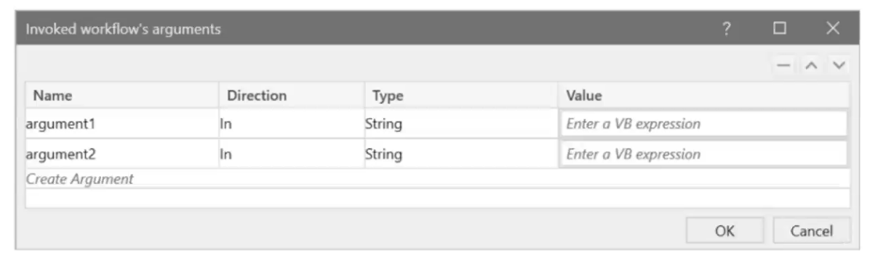

**A**In arguments can be given Hard-coded values or variables. In/out and out arguments can only be given variables.

**B**In arguments can only be given Hard-coded values. In/out and out arguments can only be given variables.

**C**In/out and out arguments can be given Hard-coded values or variables. In arguments can only be given variables.

**D**Only variables can be configured for all types of arguments.

[Hide Answer](https://www.pass4success.com/uipath/discussions/exam-uipath-adav1-topic-1-question-15-discussion)

**Suggested Answer:** *A*

In the Import Arguments panel of the Invoke Workflow File activity, in arguments can be given either hard-coded values or variables. In contrast, in/out and out arguments can only be given variables. This is because in/out and out arguments are designed to return data, so they need to be stored in variables to capture any changes made during the invoked workflow execution.

Question #: 16  
Topic #: 1

[**[All UiPath-ADAv1 Questions]**](https://www.pass4success.com/uipath/exam/uipath-adav1)

A variable should be created and used for storing one or multiple IDs. The collection of IDs can be updated during the execution of the robot by adding elements. Which should be the data type of this variable, taking into account that each of the IDs has the following format: XX-XX-XX (where X is a digit)?

**A**List<lnt32>

**B**List<String>

**C**String

**D**String[]

[Hide Answer](https://www.pass4success.com/uipath/discussions/exam-uipath-adav1-topic-1-question-16-discussion)

**Suggested Answer:** *B*

For storing one or multiple IDs with the format XX-XX-XX (where X is a digit) and allowing for updates during execution, the appropriate data type is List<String>. This is because you need a collection that can dynamically expand as more IDs are added, and the IDs are in a string format due to the inclusion of the hyphen characters. Reference:

UiPath Studio Guide: The Main Data Types in Studio

Question #: 17  
Topic #: 1

[**[All UiPath-ADAv1 Questions]**](https://www.pass4success.com/uipath/exam/uipath-adav1)

When using Invoke Workflow File, in the import arguments panel, what types of expressions can be used in the value column?



**A**In arguments can be given Hard-coded values or variables. In/out and out arguments can only be given variables.

**B**In arguments can only be given Hard-coded values. In/out and out arguments can only be given variables.

**C**In/out and out arguments can be given Hard-coded values or variables. In arguments can only be given variables.

**D**Only variables can be configured for all types of arguments.

[Hide Answer](https://www.pass4success.com/uipath/discussions/exam-uipath-adav1-topic-1-question-17-discussion)

**Suggested Answer:** *A*

In the Import Arguments panel of the Invoke Workflow File activity, in arguments can be given either hard-coded values or variables. In contrast, in/out and out arguments can only be given variables. This is because in/out and out arguments are designed to return data, so they need to be stored in variables to capture any changes made during the invoked workflow execution.

UiPath Studio Guide: Invoking Workflows and Managing Arguments

Question #: 18  
Topic #: 1

[**[All UiPath-ADAv1 Questions]**](https://www.pass4success.com/uipath/exam/uipath-adav1)

Which option best describes a process that is considered SEMI-AUTOMATION?

**A**Processes where change is frequent, the system environment is volatile, and multiple manual (even non-digital) actions are required.

**B**Processes that are digital and involve a highly static system and process environment, so that they can be easily broken into instructions and simple triggers can be defined.

**C**Processes that are rather digital and can be automated, but use some technologies that are complex (such as OCR) or require advanced programming skills.

**D**Processes that can be broken down into steps that can be clearly automated, and steps that need to stay manual (such as validations or usage of physical security tokens).

[Hide Answer](https://www.pass4success.com/uipath/discussions/exam-uipath-adav1-topic-1-question-18-discussion)

**Suggested Answer:** *D*

A process that is considered semi-automation is one where certain steps can be automated while others must remain manual. This may include actions such as validations or the use of physical security tokens that cannot be automated. Therefore, the best description of semi-automation is option D.

Question #: 19  
Topic #: 1

[**[All UiPath-ADAv1 Questions]**](https://www.pass4success.com/uipath/exam/uipath-adav1)

Which is the recommended variable type for storing password values that are composed solely of numbers?

**A**SecureString

**B**Int32

**C**String

**D**Int64

[Hide Answer](https://www.pass4success.com/uipath/discussions/exam-uipath-adav1-topic-1-question-19-discussion)

**Suggested Answer:** *A*

The recommended variable type for storing password values, even if they are composed solely of numbers, is SecureString. A SecureString is designed to provide a more secure way to handle sensitive information as it keeps the data encrypted in memory, making it less vulnerable to potential risks such as memory dumps compared to regular string types.

UiPath Activities Guide: SecureString Activities

Question #: 28  
Topic #: 20

[**[All UiPath-ADAv1 Questions]**](https://www.pass4success.com/uipath/exam/uipath-adav1)

A developer has created an automation that utilizes an Asset value from Orchestrator with the Get Asset activity. This value represents the email addresses of the process

owners, which are subject to change.

What Asset type is most suitable for this situation?

**A**Integer

**B**Bool

**C**Text

**D**Credential

[Hide Answer](https://www.pass4success.com/uipath/discussions/exam-uipath-adav1-topic-20-question-28-discussion)

**Suggested Answer:** *C*

In the context of an automation that utilizes Asset values from Orchestrator representing email addresses, the most suitable Asset type is 'Text'. The 'Text' type allows for the storage of string values, which is appropriate for email addresses. Other types like Integer, Bool, and Credential are not suitable for storing email addresses.

UiPath Orchestrator Guide: About Assets

Question #: 31  
Topic #: 8

[**[All UiPath-ADAv1 Questions]**](https://www.pass4success.com/uipath/exam/uipath-adav1)

Which option best describes a process that is considered SEMI-AUTOMATION?

**A**Processes where change is frequent, the system environment is volatile, and multiple manual (even non-digital) actions are required.

**B**Processes that are digital and involve a highly static system and process environment, so that they can be easily broken into instructions and simple triggers can be defined.

**C**Processes that are rather digital and can be automated, but use some technologies that are complex (such as OCR) or require advanced programming skills.

**D**Processes that can be broken down into steps that can be clearly automated, and steps that need to stay manual (such as validations or usage of physical security tokens).

[Hide Answer](https://www.pass4success.com/uipath/discussions/exam-uipath-adav1-topic-8-question-31-discussion)

**Suggested Answer:** *D*

A process that is considered semi-automation is one where certain steps can be automated while others must remain manual. This may include actions such as validations or the use of physical security tokens that cannot be automated. Therefore, the best description of semi-automation is option D.

Question #: 26  
Topic #: 13

[**[All UiPath-ADAv1 Questions]**](https://www.pass4success.com/uipath/exam/uipath-adav1)

A developer has designed an automation workflow which comprises:

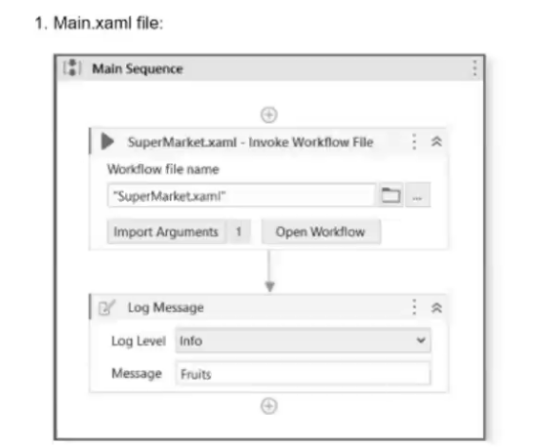

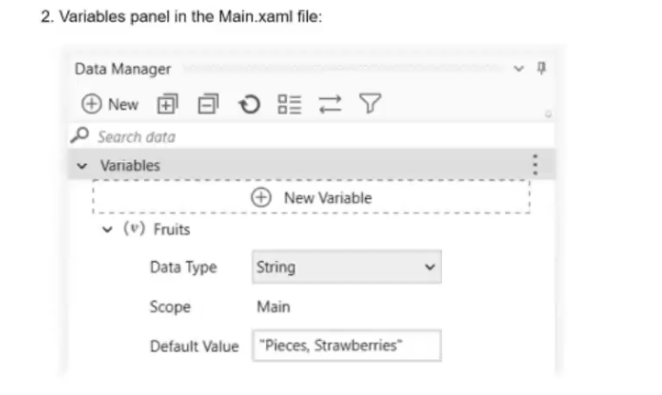

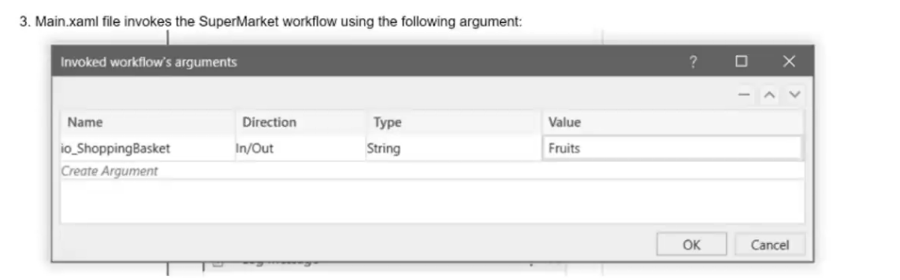

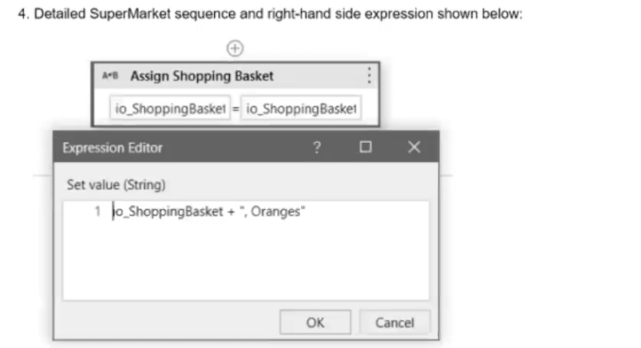

Based on the information shown in the exhibits, what is the output of the Write Line activity in the "Main.xaml" file?

**A**Pieces, Strawberries, Oranges

**B**Oranges

**C**, Oranges

**D**Pieces, Strawberries

[Hide Answer](https://www.pass4success.com/uipath/discussions/exam-uipath-adav1-topic-13-question-26-discussion)

**Suggested Answer:** *A*

Based on the information from the exhibits, the 'Main.xaml' file has a variable Fruits with a default value 'Pieces, Strawberries'. This variable is passed as an in/out argument io\_ShoppingBasket to the 'SuperMarket.xaml' workflow. Inside the 'SuperMarket.xaml' workflow, 'Oranges' is appended to io\_ShoppingBasket. Since io\_ShoppingBasket is an in/out argument, the value of Fruits in the 'Main.xaml' file will be updated to 'Pieces, Strawberries, Oranges'. Therefore, the output of the Write Line activity in the 'Main.xaml' file will be 'Pieces, Strawberries, Oranges'.

UiPath Studio Guide: Arguments

Question #: 29  
Topic #: 11

[**[All UiPath-ADAv1 Questions]**](https://www.pass4success.com/uipath/exam/uipath-adav1)

What are the components of a process?

**A**Procedures, Dependencies, Variations, Resources.

**B**Compliance, Operational Needs, Risk Management, Improvement.

**C**Inputs, Process Flows, Source Applications, Outputs.

**D**Technical Skills, Business Processes, Decision Points.

[Hide Answer](https://www.pass4success.com/uipath/discussions/exam-uipath-adav1-topic-11-question-29-discussion)

**Suggested Answer:** *C*

The components of a process typically include 'Inputs, Process Flows, Source Applications, Outputs'. This refers to what the process takes as input (data/files), the sequence of steps or activities that define the process (process flows), the applications involved in the process (source applications), and what the process produces or affects (outputs).

Question #: 27  
Topic #: 2

[**[All UiPath-ADAv1 Questions]**](https://www.pass4success.com/uipath/exam/uipath-adav1)

A variable should be created and used for storing one or multiple IDs. The collection of IDs can be updated during the execution of the robot by adding elements. Which should be the data type of this variable, taking into account that each of the IDs has the following format: XX-XX-XX (where X is a digit)?

**A**List<lnt32>

**B**List<String>

**C**String

**D**String[]

[Hide Answer](https://www.pass4success.com/uipath/discussions/exam-uipath-adav1-topic-2-question-27-discussion)

**Suggested Answer:** *B*

For storing one or multiple IDs with the format XX-XX-XX (where X is a digit) and allowing for updates during execution, the appropriate data type is List<String>. This is because you need a collection that can dynamically expand as more IDs are added, and the IDs are in a string format due to the inclusion of the hyphen characters. Reference:

UiPath Studio Guide: The Main Data Types in Studio

Question #: 29  
Topic #: 11

[**[All UiPath-ADAv1 Questions]**](https://www.pass4success.com/uipath/exam/uipath-adav1)

What are the components of a process?

**A**Procedures, Dependencies, Variations, Resources.

**B**Compliance, Operational Needs, Risk Management, Improvement.

**C**Inputs, Process Flows, Source Applications, Outputs.

**D**Technical Skills, Business Processes, Decision Points.

[Hide Answer](https://www.pass4success.com/uipath/discussions/exam-uipath-adav1-topic-11-question-29-discussion)

**Suggested Answer:** *C*

The components of a process typically include 'Inputs, Process Flows, Source Applications, Outputs'. This refers to what the process takes as input (data/files), the sequence of steps or activities that define the process (process flows), the applications involved in the process (source applications), and what the process produces or affects (outputs).

UiPath Studio Guide: Project Organization Best Practices

Question #: 30  
Topic #: 20

[**[All UiPath-ADAv1 Questions]**](https://www.pass4success.com/uipath/exam/uipath-adav1)

In order to make the selector specifically target the "First Name" text field during runtime, the developer needs to select one additional Property checkbox from the

Unselected Items column in the UI Explorer.

Which is the additional Property checkbox in the following UI Explorer "Unselected Items" column that should be used for the First Name text field.

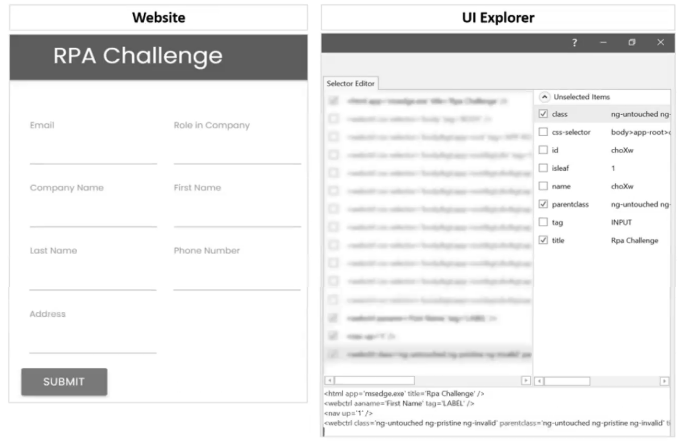

**A**tag

**B**id

**C**isleaf

**D**name

[Hide Answer](https://www.pass4success.com/uipath/discussions/exam-uipath-adav1-topic-20-question-30-discussion)

**Suggested Answer:** *B*

To make a selector specifically target the 'First Name' text field during runtime in the UI Explorer, the property that uniquely identifies the 'First Name' field should be used. Based on the information provided, the most suitable property to use is the 'id' as it is likely to be unique for each field in a form, which helps in precisely identifying the UI element.

UiPath Studio Guide: Selectors

Actual exam question for UiPath's UiPath-ADAv1 exam

Question #: 28  
Topic #: 20

[**[All UiPath-ADAv1 Questions]**](https://www.pass4success.com/uipath/exam/uipath-adav1)

A developer has created an automation that utilizes an Asset value from Orchestrator with the Get Asset activity. This value represents the email addresses of the process

owners, which are subject to change.

What Asset type is most suitable for this situation?

**A**Integer

**B**Bool

**C**Text

**D**Credential

[Hide Answer](https://www.pass4success.com/uipath/discussions/exam-uipath-adav1-topic-20-question-28-discussion)

**Suggested Answer:** *C*

In the context of an automation that utilizes Asset values from Orchestrator representing email addresses, the most suitable Asset type is 'Text'. The 'Text' type allows for the storage of string values, which is appropriate for email addresses. Other types like Integer, Bool, and Credential are not suitable for storing email addresses.

UiPath Orchestrator Guide: About Assets

Question #: 25  
Topic #: 2

[**[All UiPath-ADAv1 Questions]**](https://www.pass4success.com/uipath/exam/uipath-adav1)

In the case of accidentally starting a process from UiPath Assistant, where should the user manually terminate the execution?

**A**The user should end the execution by terminating the UiPath Robot service from the Task Manager.

**B**The user should end the execution from the 'Home' tab and locate the running process associated with the execution.

**C**The user should end the execution by closing the UiPath Assistant application.

**D**The user should end the execution from the 'Jobs' tab in UiPath Assistant.

[Hide Answer](https://www.pass4success.com/uipath/discussions/exam-uipath-adav1-topic-2-question-25-discussion)

**Suggested Answer:** *D*

If a process is accidentally started from UiPath Assistant, the user should manually terminate the execution from the 'Jobs' tab in UiPath Assistant. This tab shows the list of running processes, where the user can stop the unintended process.

UiPath Assistant Guide: Managing Jobs

Question #: 24  
Topic #: 20

[**[All UiPath-ADAv1 Questions]**](https://www.pass4success.com/uipath/exam/uipath-adav1)

In order to make the selector specifically target the "First Name" text field during runtime, the developer needs to select one additional Property checkbox from the

Unselected Items column in the UI Explorer.

Which is the additional Property checkbox in the following UI Explorer "Unselected Items" column that should be used for the First Name text field.



**A**tag

**B**id

**C**isleaf

**D**name

[Hide Answer](https://www.pass4success.com/uipath/discussions/exam-uipath-adav1-topic-20-question-24-discussion)

**Suggested Answer:** *B*

To make a selector specifically target the 'First Name' text field during runtime in the UI Explorer, the property that uniquely identifies the 'First Name' field should be used. Based on the information provided, the most suitable property to use is the 'id' as it is likely to be unique for each field in a form, which helps in precisely identifying the UI element.

UiPath Studio Guide: Selectors

Question #: 23  
Topic #: 13

[**[All UiPath-ADAv1 Questions]**](https://www.pass4success.com/uipath/exam/uipath-adav1)

What types of authentication are supported by Connector Builder for Integration Service?

**A**OAuth 2.0 Authorization Code, OAuth 2.0 Client Credentials, SSL, OAuth 2.0 Implicit Grant, LDAP, RADIUS.

**B**OAuth 2.0 Authorization Code, OAuth 2.0 Authorization code with PKCE, OAuth 2.0 Client Credentials, Basic, API Key, Personal Access Token (PAT), No Authentication.

**C**OAuth 2.0 Authorization Code, OAuth 2.0 Authorization code with PKCE, Basic, Windows Authentication, API Key, Kerberos.

**D**OAuth 1.0, OAuth 2.0 Authorization Code, OAuth 2.0 Client Credentials, SAML, JWT, Lightweight Directory Access Protocol.

[Hide Answer](https://www.pass4success.com/uipath/discussions/exam-uipath-adav1-topic-13-question-23-discussion)

**Suggested Answer:** *B*

The types of authentication supported by Connector Builder for Integration Service include various OAuth 2.0 flows, Basic authentication, API Key, and Personal Access Token (PAT). The correct option that lists these authentication types is B, which includes OAuth 2.0 Authorization Code, OAuth 2.0 Authorization code with PKCE (Proof Key for Code Exchange), OAuth 2.0 Client Credentials, Basic, API Key, and Personal Access Token (PAT), along with No Authentication.

UiPath Integration Service Documentation: Authentication Types in Integration Service

Question #: 22  
Topic #: 8

[**[All UiPath-ADAv1 Questions]**](https://www.pass4success.com/uipath/exam/uipath-adav1)

Which option from the UiPath Studio backstage view prohibits debugging projects with Workflow Analyzer errors?

**A**Enforce Analyzer before remote execution.

**B**Enforce Analyzer before Push/Check-in.

**C**Enforce Analyzer before Publish,

**D**Enforce Analyzer before Run.

[Hide Answer](https://www.pass4success.com/uipath/discussions/exam-uipath-adav1-topic-8-question-22-discussion)

**Suggested Answer:** *D*

In UiPath Studio, the option that prohibits debugging projects with Workflow Analyzer errors is 'Enforce Analyzer before Run.' When this option is enabled in the backstage view, the Workflow Analyzer runs before the execution of the project, and if there are errors, the project will not run.

UiPath Studio Guide: Workflow Analyzer

Question #: 21  
Topic #: 7

[**[All UiPath-ADAv1 Questions]**](https://www.pass4success.com/uipath/exam/uipath-adav1)

A process workflow contains a Try Catch activity that is designed to catch and stop when any unknown System Exceptions occur. What would be the recommended Log Level

for the Log Message contained in the System Exception block?

**A**Info

**B**Warn

**C**Fatal

**D**Error

[Hide Answer](https://www.pass4success.com/uipath/discussions/exam-uipath-adav1-topic-7-question-21-discussion)

**Suggested Answer:** *C*

The recommended Log Level for the Log Message activity that is contained within the System Exception block of a Try Catch activity designed to catch and stop for any unknown System Exceptions is 'Fatal.' This level is used to indicate that a critical error has occurred, typically one that leads to a termination of the application.

UiPath Studio Guide: Logging Levels

Question: 1 What are the primary functions of the UiPath Integration Service? A. Enables automation with a library of connectors, manages connections easily with standardized authentication, kicks off automations with server-side triggers or events, provides curated activities and events, simplifies automation design. B. Automates Ul design, manages API connections, provides limited activities and events, simplifies automation design. C. Enables automation with API integration, manages connections with user-provided authentication, kicks off automations based on application-specific triggers, simplifies automation design with the help of third-party libraries. D. Enables automation with Ul components, manages API keys, kicks off automations with client-side triggers, provides curated events. Answer: A Explanation: UiPath Integration Service is a component of the UiPath Platform that allows users to automate third-party applications using both UI and API integration. It has the following primary functions1: Enables automation with a library of connectors: Connectors are pre-built API integrations that provide a consistent developer experience and simplify the integration process. Users can browse and import connectors from the Connector Catalog or the UiPath Marketplace, or create their own connectors using the Connector Builder (Preview). Manages connections easily with standardized authentication: Users can create and manage secure connections to various applications using standardized authentication methods, such as OAuth 2.0, Basic, API Key, etc. Users can also share connections with other users, groups, or automations within the UiPath Platform. Kicks off automations with server-side triggers or events: Users can trigger automations based on events from external applications, such as webhooks, email, or schedules. Users can also configure parameters and filters for the events to customize the automation logic. Provides curated activities and events: Users can access a set of curated activities and events that are specific to each connector and application. These activities and events can be used in UiPath Studio or UiPath StudioX to design and execute automations. Simplifies automation design: Users can leverage the UiPath Integration Service Designer to create and test integrations in a graphical interface. Users can also import common API formats, such as Swagger, YAML, or Postman collections, to generate connectors automatically. Reference: 1: Integration Service - Introduction - UiPath Documentation Portal Questions & Answers PDF Page 3 Question: 2 What happens when closing a Remote Debugging Connection while a debugging execution is in progress? A. The remote robot continues the execution after Studio closes the connection. B. Debugging execution ends in exception, then the connection is closed. C. Debugging execution stops gracefully, then the connection is closed. D. It is not possible to close the connection while debugging is in progress. Answer: C Explanation: When you close a remote debugging connection while a debugging execution is in progress, the execution is stopped gracefully on the remote robot and the connection is closed. This means that the robot will finish the current activity and then stop the execution, without throwing any exception or error. This is the recommended way to end a remote debugging session, as it ensures that the robot is in a consistent state and ready for the next execution. Reference: [Remote Debugging] Question: 3 Where is the TransactionNumber incremented in the REFramework? A. Only in the RetryCurrentTransaction.xaml workflow. B. Only in the SetTransactionStatus.xaml workflow. C. In the New Transaction transition. D. In the RetryCurrentTransaction.xaml workflow and in the SetTransactionStatus.xaml workflow. Answer: B Explanation: The TransactionNumber is incremented only in the SetTransactionStatus.xaml workflow, which is invoked at the end of each transaction. This workflow updates the status of the current transaction item in Orchestrator and increments the TransactionNumber by one. The TransactionNumber is used to keep track of the number of transactions processed by the robot and to get the next transaction item from the queue. Reference: [SetTransactionStatus.xaml] Question: 4 Which logging level includes the following information by default? 1. Execution Started log entry - generated every time a process is started. 2. Execution Ended log entry - generated every time a process is finalized. 3. Transaction Started log entry - generated every time a transaction item is obtained by the robot Questions & Answers PDF Page 4 from Orchestrator. 4. Transaction Ended log entry - generated every time the robot sets the transaction status to either Success or Failed. 5. Activity Information log entry - generated every time an activity is started, faulted or finished inside a workflow. 6. Arguments and Variables Information log entry - show values of the variables and arguments that are used. A. Verbose B. Trace C. Critical D. Information Answer: A Explanation: The Verbose logging level includes the following information by default: Execution Started log entry - generated every time a process is started. Execution Ended log entry - generated every time a process is finalized. Transaction Started log entry - generated every time a transaction item is obtained by the robot from Orchestrator. Transaction Ended log entry - generated every time the robot sets the transaction status to either Success or Failed. Activity Information log entry - generated every time an activity is started, faulted or finished inside a workflow. Arguments and Variables Information log entry - show values of the variables and arguments that are used. The Verbose logging level is the most detailed one and it is useful for debugging purposes, as it provides a lot of information about the execution flow and the data used by the robot. However, it also generates a lot of log entries, which can affect the performance and the storage space of the robot and Orchestrator. Reference: [Logging Levels] Question: 5 How would you define a linear process in UiPath? A. The steps of the process refer to the execution of steps in a sequential manner, where each subsequent step depends on the successful completion of the previous step. B. The steps of the process are performed multiple times, but each time different data items are used. C. The steps of the process repeat multiple times over different data items. However, the automation design is such that each repeatable part processes independently. D. The process steps are performed only once. If the need is to process additional data, then the automation must execute again. Answer: D Questions & Answers PDF Page 5 Explanation: A linear process in UiPath is a type of process that is executed only once and does not involve any looping or branching logic. It is suitable for simple scenarios where the input data is fixed and the output is predictable. A linear process can be designed using a Sequence or a Flowchart diagram, but it does not use any Flow Decision, Switch, While, Do While, or For Each activity. If the process needs to process additional data, then the automation must be executed again with the new data as input. Reference: Framework for linear process or single transaction, How to modify ReFramework to Linear Process, Workflow Design, Difference between Linear process and Transactional process

Recommend!! Get the Full UiPath-ADAv1 dumps in VCE and PDF From SurePassExam https://www.surepassexam.com/UiPath-ADAv1-exam-dumps.html (195 New Questions) UiPath Exam Questions UiPath-ADAv1 UiPath Automation Developer Associate v1 Exam Passing Certification Exams Made Easy visit - https://www.surepassexam.com Recommend!! Get the Full UiPath-ADAv1 dumps in VCE and PDF From SurePassExam https://www.surepassexam.com/UiPath-ADAv1-exam-dumps.html (195 New Questions) NEW QUESTION 1 A developer is working with a Purchase Order automation process The number of shipment containers and boxes per container are obtained in two strings, "ShipmentContainers" and "BoxesPerContainer" The task is for the robot to obtain the total number of boxes in all shipment containers in an Int32 variable TotalBoxes. Which expression should be used for calculating the total number of boxes? A. Convert Tolnt32(ShipmentContainers) \* Convert Tolnt32(BoxesPerContamer) B. ShipmentContainers.Tolnt() \* BoxesPerContainer Tolnt() C. ShipmentContamersTolnt32() \* BoxesPerContainer.Tolnt32() D. ShipmentContamers \* BoxesPerContainer Answer: A Explanation: To calculate the total number of boxes in all shipment containers, the expression that should be used is: Convert.ToInt32(ShipmentContainers) \* Convert.ToInt32(BoxesPerContainer) This expression converts the two strings, “ShipmentContainers” and “BoxesPerContainer”, into integer values using the Convert.ToInt32 method. This method converts the specified string representation of a 32-bit signed integer to an equivalent integer value1. Then, the expression multiplies the two integer values to obtain the total number of boxes. For example, if “ShipmentContainers” is “5” and “BoxesPerContainer” is “10”, then the expression will return 50 as the total number of boxes. References: Convert.ToInt32 Method from UiPath documentation. NEW QUESTION 2 Which Control Flow activity is suitable for a developer who needs to assess the value of a counter before executing the loop's body in a workflow? A. Do While B. Switch C. )While D. If Answer: C Explanation: The While activity is a Control Flow activity that enables the developer to execute a specified part of the automation while a condition is met. The condition is evaluated before the loop body is executed, which means that the developer can assess the value of a counter or any other variable before performing the actions inside the loop. This type of activity can be useful to iterate through an array, a list, a data table, or any other collection of data, or to repeat an action until a certain value is reached or changed. The While activity can be found in the Activities panel, under Workflow > Control. References: ? While - UiPath Activities ? While Activity - UiPath Studio ? UiPath While Loop Tutorial with Examples - RPA Tutorial NEW QUESTION 3 What is a pre-requisite for running InitAllApplications TestCase? A. Invoke CloseAllApplications XAML file in Given. B. Invoke KillAllProcesses XAML file in Given. C. Invoke InitAllSettings XAML file in Given. D. Invoke SetTransactionStatus XAML file in Given. Answer: C Explanation: The InitAllApplications TestCase is used to test the initialization of all the applications that are required for the automation process1. The pre-requisite for running this TestCase is to invoke the InitAllSettings XAML file in the Given section of the TestCase2. The InitAllSettings file is responsible for reading the configuration data from the Config.xlsx file and storing it in a dictionary variable3. This data is then used by the InitAllApplications file to open and log in to the applications using the credentials and URLs from the dictionary variable4. NEW QUESTION 4 A developer has declared a variable of type String named StrVar and assigned it the value "UIPATH STUDIO". What is the output of the expression, StrVar.lndexOf("U")? A. 1 B. 9 C. 10 Answer: A Explanation: The IndexOf method of String values returns the index of the first occurrence of a specified character or substring in a given string. The index is zero-based, meaning that the first character has the index 0, the second character has the index 1, and so on. If the character or substring is not found, the method returns -1. In this case, the expression StrVar.IndexOf(“U”) returns the index of the first occurrence of the character “U” in the string “UIPATH STUDIO”, which is 0. Therefore, the answer is A. 0. References: String.IndexOf Method, String Variables NEW QUESTION 5 A developer is automating the process of entering sensitive information into text input fields that are constantly changing their position. Each text input field has a corresponding text label. The developer decides to automate the process by using Modern UI Activities with anchors. Which activities should be used? Passing Certification Exams Made Easy visit - https://www.surepassexam.com Recommend!! Get the Full UiPath-ADAv1 dumps in VCE and PDF From SurePassExam https://www.surepassexam.com/UiPath-ADAv1-exam-dumps.html (195 New Questions) A. Find Text Position activity as the anchor and Type Secure Text activity as the action. B. Type Into activity with a valid anchor and the input text provided in the Secure Text property. C. Find Text Position activity as the anchor and Set Text activity as the action. D. Type Into activity with a valid anchor and the input text provided in the Text property. Answer: A Explanation: The Find Text Position activity is used to find the position of a text on the screen and return it as a UiElement variable. This can be used as an anchor to locate the text input field that corresponds to the text label. The Type Secure Text activity is used to type a password or other sensitive information into a UI element, without revealing the actual text. The input text is provided as a SecureString variable, which is encrypted and cannot be viewed in plain text. This ensures that the sensitive information is entered securely and accurately into the text input field. References: ? Find Text Position - UiPath Activities ? Type Secure Text - UiPath Activities ? UiPath Anchor Base Tutorial & AnchorPosition Example NEW QUESTION 6 A developer created an automation which scrapes data from PDF reports. The reports have the same structure and the title format is always "Report X - PDF"T where X is a number from 1 to 100. Only one report will be open at a time but other PDF files may be open on the desktop. What is the recommended method to ensure the selector identifies the correct PDF to use? A. Use the \* wildcard character in place of the idx attribute value B. Use the idx attribute value in the selector to increment for each file C. Use the \* wildcard character in place of the title attribute value D. Use the \* wildcard character in place of the "X" in the title attribute value Answer: D Explanation: The recommended method to ensure the selector identifies the correct PDF to use is to use the \* wildcard character in place of the “X” in the title attribute value. The \* wildcard character is a symbol that can replace zero or more characters in a string. It can be used to handle dynamic elements in a selector, such as the title of a PDF file that changes for each report2. For example, if the selector for the PDF file is: Then the selector can be modified as: This selector will match any PDF file that has a title starting with “Report” and ending with “PDF”, regardless of the number in between. This way, the selector can identify the correct PDF file to use, even if other PDF files are open on the desktop, as long as only one report is open at a time. References: Selectors with Wildcards and Wildcards in selector from UiPath documentation and forum. NEW QUESTION 7 A developer defines new log fields using the Add Log Fields activity. When will the custom log fields stop being added to the robot execution logs? A. When an Exception is caught and handled. B. When a Remove Log Fields activity is used to remove them. C. When a Log Message activity is executed with Log Level = Warn or higher. D. When the first Log Message activity is executed. Answer: B Explanation: The Add Log Fields activity adds custom log fields to the Robot Execution Logs for every Log Message execution throughout the entire workflow1. The custom log fields will persist until a Remove Log Fields activity is used to remove them2. The other options are not correct. References: ? Add Log Fields documentation, Description section ? Add log field forum post, Answer by @vvaidya NEW QUESTION 8 In a UiPath REFramework project, what is the primary purpose of using Custom Log Fields? A. To add specific contextual information to log messages that are relevant to the automation process. B. To generate extra variables alongside log messages, enhancing workflow understanding. C. To maintain contextual insights within log messages, including secure details like credentials. D. To modify the representation of logged contextual data as it is displayed in the Orchestrator. Answer: A Explanation: The Add Log Fields activity allows developers to create custom log fields that are added to the Robot Execution Logs. These custom log fields can be used to store and display additional information that is relevant to the automation process, such as transaction ID, invoice number, customer name, etc. The custom log fields can help to improve the traceability and analysis of the automation process, as well as to filter and group the logs based on specific criteria. (UiPath Automation Developer study guide) References: ? Add Log Fields ? Logging and Log Levels NEW QUESTION 9 What is the purpose of the Interval filter in the Orchestrator's Monitoring page? Passing Certification Exams Made Easy visit - https://www.surepassexam.com Recommend!! Get the Full UiPath-ADAv1 dumps in VCE and PDF From SurePassExam https://www.surepassexam.com/UiPath-ADAv1-exam-dumps.html (195 New Questions) A. It allows you to control the granularity of the displayed data and check the health of your system in either the last day or the last hour. B. It allows you to allocate licenses per machine for the displayed data. C. It allows you to choose between background and foreground processes for the displayed data. D. It enables you to sort the displayed data based on job priorities. Answer: A Explanation: The Interval filter in the Orchestrator’s Monitoring page lets you select the time range for the data that is displayed on the dashboard1. You can choose between Last Day and Last Hour options to view the performance and health indicators of your system at different levels of detail2. References: ? Monitoring documentation, Interval Filter section ? UiPath Orchestrator Monitoring video, 2:10 - 2:30 NEW QUESTION 10 Which of the following statements is true about Global Constants? A. Global Constants can be created only from the Data Manager panel. B. Global Constants values can be modified during the automation execution. C. Global Constants have a Direction property (In/Out). D. Global Constants can be created from the Data Manager panel and from the Variables panel. Answer: D Explanation: Global Constants are a type of variables that can store data in a central location that can be accessed by all workflows and activities in a project. Unlike Global Variables, Global Constants have a fixed value that cannot be modified during the automation execution. Global Constants can be created from two places in UiPath Studio: the Data Manager panel and the Variables panel. The Data Manager panel is a new feature in UiPath 2022.10 that allows the developer to manage all the data elements of a project, such as variables, arguments, data types, and data sources. The Variables panel is a classic feature that allows the developer to create and edit variables for a specific workflow. To create a Global Constant from the Data Manager panel, the developer needs to select the Constants tab, click on the New Constant button, and fill in the required fields, such as name, type, value, and description. To create a Global Constant from the Variables panel, the developer needs to select the Global scope, click on the Create Variable button, and fill in the required fields, such as name, type, value, and description. In both cases, the developer needs to make sure that the Is Constant option is checked, which indicates that the variable is a constant and cannot be changed. References: ? Global Variables and Constants - UiPath Community Forum ? Data Manager - UiPath Studio ? Variables Panel - UiPath Studio NEW QUESTION 11 Which activity can be used to transition a Background Process to Foreground? A. Use Foreground B. Activate C. Maximize Window D. Set Focus Answer: A Explanation: The Use Foreground activity can be used to transition a Background Process to Foreground. It allows you to perform UI automation tasks that require user interaction or visibility1. The other activities are not suitable for this purpose. References: ? Background Process Automation documentation, Transitioning a Background Process to Foreground section NEW QUESTION 12 HOTSPOT A developer created three variables used in the workflow shown below: Passing Certification Exams Made Easy visit - https://www.surepassexam.com Recommend!! Get the Full UiPath-ADAv1 dumps in VCE and PDF From SurePassExam https://www.surepassexam.com/UiPath-ADAv1-exam-dumps.html (195 New Questions) Instructions: Based on best practices, select the correct Scope for each Variable type from the drop-down lists shown in the following exhibit. Passing Certification Exams Made Easy visit - https://www.surepassexam.com Recommend!! Get the Full UiPath-ADAv1 dumps in VCE and PDF From SurePassExam https://www.surepassexam.com/UiPath-ADAv1-exam-dumps.html (195 New Questions) Solution: Name = Age Variable type = Double Scope = Body of For Each Row Name = TimeonThePlanet Variable type = Time Span Scope = Sequence - Yes, Can Vote Name = dt\_NamesBirthdays Variable type = DataTable Scope = Voter Registration The reason for choosing these scopes is to keep the variables in the innermost scope where they are used and to avoid unnecessary clutter and duplication in the Variables panel. You can learn more about variable scope in UiPath from the following sources: ? Variable scope - Studio - UiPath Community Forum ? How Variable Scope Works in UiPath - Video Tutorials - UiPath Community Forum ? How to pass variables as UiPath arguments example - TheServerSide ? Best Practices: Select Variables scope - UiPath Community Forum Does this meet the goal? A. Yes B. No Answer: A NEW QUESTION 13 A developer implemented a process using the Robotic Enterprise Framework and an Orchestrator queue. The MaxRetryNumber from the "Config.xlsx" file is set to "1" and the Max # of retries from the Queue settings from Orchestrator is set to "2". At runtime, the first transaction item throws a Business Exception. How many times will the transaction be retried? A. The transaction will be retried only one time. B. The transaction will not be retried. C. The transaction will be retried 2 times. D. The transaction will be retried multiple times, until it will be processed successfully. Answer: B Explanation: The Robotic Enterprise Framework (REF) is a template that provides a structured and consistent way to develop automation processes. The REF uses an Orchestrator queue to store and process the transaction items, which are the units of work for the process. The REF also handles different types of exceptions that may occur during the execution of the process, such as system exceptions and business exceptions. A system exception is an error that prevents the normal execution of the process, such as a network failure or an application crash. A business exception is an error that is related to the business logic or rules of the process, such as an invalid input or an incorrect output. The REF has different mechanisms to deal with these exceptions, such as retrying, logging, and updating the status of the transaction items. The MaxRetryNumber from the “Config.xlsx” file is a parameter that specifies how many times the REF will retry a transaction item when a system exception occurs. The Max # of retries from the Queue settings from Orchestrator is a parameter that specifies how many times Orchestrator will retry a transaction item when it changes to Failed status due to any exception. These two parameters are independent of each other and have different effects on the retry mechanism. In this case, the first transaction item throws a business exception, which means that there is something wrong with the data or the logic of the process. The REF will not retry a transaction item when a business exception occurs, because it assumes that retrying will not solve the problem. Instead, the REF will log the exception, update the status of the transaction item to Failed, and move on to the next transaction item. Orchestrator will also not retry a transaction item when it changes to Failed status due to a business exception, because it respects the decision of the REF. Therefore, the transaction will not be retried at all. References: ? 1: Robotic Enterprise Framework Template - UiPath Studio. NEW QUESTION 14 What actions must be manually selected in the App/Web Recorder before recording a step? A. Copy text using the Get Text activity.Hover over an element using the Hover activit B. Highlight an element using the Highlight activity. C. Copy text using the Get Text activity.Hover over an element using the Hover activity.Click on buttons, links, and other clickable elements such as icons or image D. Type text in a text area such as a text box.Select or clear a check box. E. Select or clear a check box.Send keyboard shortcuts using your keyboar F. Select an item from a drop-down. G. Click on buttons, links, and other clickable elements such as icons or image H. Type text in a text area such as a text box.Select or clear a check box.Send keyboard shortcuts using your keyboar I. Select an item from a drop-down. Answer: A Passing Certification Exams Made Easy visit - https://www.surepassexam.com Recommend!! Get the Full UiPath-ADAv1 dumps in VCE and PDF From SurePassExam https://www.surepassexam.com/UiPath-ADAv1-exam-dumps.html (195 New Questions) Explanation: The App/Web Recorder is a tool that allows you to record your actions on an application or a web browser and generate activities automatically1. The App/Web Recorder has a toolbar that contains different actions that you can select before recording a step2. Some of these actions are: ? Click: This action records a click on a button, link, or any other clickable element. ? Type: This action records typing text in a text box or any other text area. ? Check: This action records selecting or clearing a check box. ? Send Hotkey: This action records sending keyboard shortcuts using your keyboard. ? Select Item: This action records selecting an item from a drop-down list or any other selector. These actions are automatically detected and recorded by the App/Web Recorder when you perform them on the application or web browser3. However, there are some actions that are not automatically detected and recorded by the App/Web Recorder, and you need to manually select them from the toolbar before recording a step. These actions are: ? Get Text: This action records copying text from a label, paragraph, or any other text element. ? Hover: This action records hovering over an element with your mouse cursor. ? Highlight: This action records highlighting an element with a colored border. These actions are useful for extracting data, triggering events, or identifying elements on the application or web browser4. To use these actions, you need to select them from the toolbar and then indicate the element on the screen that you want to apply them to5. Therefore, option A is the correct answer, as it lists the actions that must be manually selected in the App/Web Recorder before recording a step. Option B includes some actions that are automatically detected and recorded by the App/Web Recorder, such as Click and Type. Option C also includes some actions that are automatically detected and recorded by the App/Web Recorder, such as Check and Send Hotkey. Option D includes all the actions that are automatically detected and recorded by the App/Web Recorder. NEW QUESTION 15 A developer needs to use the REFramework to automate a business process that involves processing transactions within an Excel table. Each transaction in the table should follow the same steps for processing and queues cannot be used as there is no Orchestrator in the environment. Which variable type is best suited for Transactionltem in this scenario? A. System.Data.DataRow B. UiPath.Core.Queueltem C. System.Dat D. DataTable E. System.Data.DataRow[] Answer: A Explanation: The REFramework template is a robust and scalable framework for building RPA projects1. It uses a state machine to handle the different stages of the automation process2. One of the states is the Process Transaction state, where the main actions are performed on each transaction item3. A transaction item can be a queue item from Orchestrator, a data row from an Excel file, or any other type of data that needs to be processed. If the transactions are stored in an Excel table, the best variable type for TransactionItem is System.Data.DataRow, as it represents a single row of data in a DataTable. A DataTable is a collection of rows and columns that can be read from or written to an Excel file using the Excel activities. Therefore, option A is correct. Option B is incorrect because UiPath.Core.QueueItem is a variable type that represents an item from a queue in Orchestrator. If there is no Orchestrator in the environment, queues cannot be used and QueueItem is not applicable. Option C is incorrect because System.Data.DataTable is a variable type that represents a table of data with rows and columns. A single transaction item cannot be a whole table, but only a row from the table. Option D is incorrect because System.Data.DataRow[] is a variable type that represents an array of data rows. An array is a collection of items of the same type that can be accessed by an index. A single transaction item cannot be an array, but only an element from the array. References: ? The UiPath ReFramework documentation from UiPath ? State Machines documentation from UiPath ? Process.xaml documentation from UiPath ? [TransactionItem Variable] documentation from UiPath ? [DataRow Class] documentation from Microsoft ? [Excel Activities] documentation from UiPath ? [QueueItem Class] documentation from UiPath ? [DataRow[] Structure] documentation from Microsoft ? [Array Class] documentation from Microsoft NEW QUESTION 16 What differentiates a List type from an Array type? A. List items can be accessed through an index but array items cannot. B. An array has a fixed, predefined number of elements while a list has a dynamic number of elements. C. A list can hold items of multiple data types at the same time while arrays cannot. D. Lists provide the option of looping through data while arrays do not. Answer: B Explanation: Both list and arrays are a collection type of variables that can store multiple values of the same data type. The main difference between them is if their size is fixed or not. Array has a fixed size, meaning that if you create an array containing 3 elements, you can’t add more than 3 or reduce its size. List has a dynamic size, meaning that you can add or remove elements as you need. List also provides some methods that can be invoked to perform operations on the elements, such as sorting, reversing, finding, etc. Array does not have such methods, but it is more optimized for arithmetic computations. References: ? Differences between a list and an array - UiPath Community Forum ? Array manipulation with UiPath (List, Dictionary, Array) - F-PenIT blog ? List Collection ArrayList - Activities - UiPath Community Forum NEW QUESTION 17 Passing Certification Exams Made Easy visit - https://www.surepassexam.com Recommend!! Get the Full UiPath-ADAv1 dumps in VCE and PDF From SurePassExam https://www.surepassexam.com/UiPath-ADAv1-exam-dumps.html (195 New Questions) While working in an RPA testing project, you encountered the following activity in one of the workflows included in the project. What action can you perform in your mocked file to replace the functionality of the MessageBox with a LogMessage during mock testing? A. Remove mock activity. B. Synchronize mock. C. Surround activity with mock. D. Create mock workflow. Answer: C Explanation: The Surround activity with mock option is used to create a mock activity that wraps around the original activity in the workflow. The mock activity can have different properties and actions than the original activity, depending on the testing scenario. In this case, the MessageBox activity can be surrounded with a mock activity that has the LogMessage action. This will replace the functionality of the MessageBox with a LogMessage during mock testing, which can be useful for logging the test results without interrupting the workflow execution. (UiPath Studio documentation1) References: ? 1: Configuring Activity Project Settings - UiPath Studio. NEW QUESTION 18 You want to identify a selector in a Type into activity that will be used for a text input field within an application. In order for the Type into activity to execute as expected, how many elements in an application can a selector be valid for at runtime? A. 1 element B. 2 elements C. 3 elements D. 5 elements Answer: A Explanation: A selector is a string of characters (XML fragment) that identifies a UI element uniquely within the UI hierarchy. A selector must be valid for only one element in an application, otherwise the Type into activity will not be able to find the correct target for typing the text. If a selector is valid for more than one element, it is considered ambiguous and unreliable. Therefore, the answer is A. 1 element. References: Selectors, Type Into NEW QUESTION 19 At indication time, the Strict Selector has the following functionalities available: A. Open in UiExplorer, Copy to clipboard, Show all matches. B. Refresh, Open in UiExplorer, Copy to clipboard. C. Accuracy, Open in UiExplorer, Copy to clipboard, Show all matches. D. Ignore text, Copy to clipboard, Show all matches. Answer: C Explanation: The Strict Selector option allows you to fine-tune the selector by adjusting the accuracy level and showing all the matches in the UI Explorer. The other options are not available at indication time. References: ? Selectors in UiPath Studio course, Lesson 3: UI Explorer, Topic: Strict Selector ? Uipath Associate Certification UiRPA Question Latest course, Section 2: UI Automation, Lecture: Question 10 NEW QUESTION 20 A developer is using the REFramework template to automate a process. In "SetTransactionStatus" file, there is the following sequence of activities, where the last Log Message activity was added by the developer: Passing Certification Exams Made Easy visit - https://www.surepassexam.com Recommend!! Get the Full UiPath-ADAv1 dumps in VCE and PDF From SurePassExam https://www.surepassexam.com/UiPath-ADAv1-exam-dumps.html (195 New Questions) The configuration for Add Log Fields and Remove Log Fields activities are shown below: Add transaction log fields (Success) Passing Certification Exams Made Easy visit - https://www.surepassexam.com Recommend!! Get the Full UiPath-ADAv1 dumps in VCE and PDF From SurePassExam https://www.surepassexam.com/UiPath-ADAv1-exam-dumps.html (195 New Questions) The developer runs the process and notices the argument values for the first transaction are: in\_TransactionlD = "07/18/2023 10:27:29" io\_TransactionNumber = 1 in\_TransactionField1 = "UI235-80" in\_TransactionField2 = "Update Request" Which of the following Log Message Details will be displayed when executing the activity Log Message Completed for the first transaction, considering it is successful? A. "message": "Transaction Completed", "level": "Information", "logType": "User", "timeStamp": "10:30:19", "fileName": "SetTransactionStatus", "processVersion": "1.0.0", "jobId": "59325301-680a-4d55-a81b-56ca1f369c12", "robotName": "test.robot", "machineId": 0, "logF\_TransactionField2": "" "logF\_TransactionStatus": "logF\_TransactionID"; "", "logF\_BusinessProcessName": "Framework", "logF\_TransactionNumber": "" "logF\_TransactionField1": } B. "message": "Transaction Completed", "level": "Information", "logType": "User", "timeStamp": "10:30:19", "fileName": "SetTransactionStatus", "processVersion": "1.0.0", "jobId": "cb865477-35f8-4c0a-93e9-e4f4246223f2", "robotName": "test.robot", "machineId": 0, "logF\_TransactionField2": "Update Request", "logF\_TransactionID": "07/18/2023 10:27:29", "logF\_BusinessProcessName": "Framework", "logF\_TransactionNumber": "1", "logF\_TransactionField1": "UI235-80", "logF\_TransactionStatus": "Success" A. "message": "Transaction Completed", "level": "Information","logType": "User","timeStamp": "10:30:19", "fileName": "SetTransactionStatus", "processVersion": "1.0.0","jobId": "f8a36a46-8ebc-40df-8f71-26b39087ebee", "robotName": "test.robot","machineId": 0, "logF\_BusinessProcessName": "Framework"}D."message": "Transaction Completed","level": "Information", "logType": "User","timeStamp": "10:30:19", "fileName": "SetTransactionStatus", "processVersion": "1.0.0","jobId": "59325301-680a-4d55-a81b-56ca1f369c12","robotName": "test.robot", "machineId": 0, "logF\_TransactionField2": empty, "logF\_TransactionStatus": empty, "logF\_TransactionID": empty,"logF\_BusinessProcessName": "Framework", "logF\_TransactionNumber": empty, "logF\_TransactionField1": empty} Answer: B Explanation: The Log Message activity is used to write a diagnostic message at a specified level to the output panel, the log file, and Orchestrator1. The message can include custom log fields that are added by the Add Log Fields activity and removed by the Remove Log Fields activity2. In this case, the developer has added six log fields in the Add transaction log fields (Success) sequence and removed three of them in the Remove transaction log fields sequence. Therefore, the remaining three log fields (logF\_TransactionField2, logF\_TransactionID, and logF\_TransactionStatus) will be displayed along with the default log fields (message, level, logType, timeStamp, fileName, processVersion, jobId, robotName, and machineId) when executing the Log Message Completed activity. The values of the log Passing Certification Exams Made Easy visit - https://www.surepassexam.com Recommend!! Get the Full UiPath-ADAv1 dumps in VCE and PDF From SurePassExam https://www.surepassexam.com/UiPath-ADAv1-exam-dumps.html (195 New Questions) fields will be taken from the corresponding arguments of the Set Transaction Status activity. References: ? Add Log Fields activity documentation from UiPath ? Remove Log Fields activity documentation from UiPath ? Log Message activity documentation from UiPath NEW QUESTION 21 ...... Passing Certification Exams Made Easy visit - https://www.surepassexam.com Recommend!! Get the Full UiPath-ADAv1 dumps in VCE and PDF From SurePassExam https://www.surepassexam.com/UiPath-ADAv1-exam-dumps.html (195 New Questions) Thank You for Trying Our Product We offer two products: 1st - We have Practice Tests Software with Actual Exam Questions 2nd - Questons and Answers in PDF Format UiPath-ADAv1 Practice Exam Features: \* UiPath-ADAv1 Questions and Answers Updated Frequently \* UiPath-ADAv1 Practice Questions Verified by Expert Senior Certified Staff \* UiPath-ADAv1 Most Realistic Questions that Guarantee you a Pass on Your FirstTry \* UiPath-ADAv1 Practice Test Questions in Multiple Choice Formats and Updatesfor 1 Year 100% Actual & Verified — Instant Download, Please Click Order The UiPath-ADAv1 Practice Test Here Powered by TCPDF (www.tcpdf.org) Passing Certification Exams Made Easy visit - <https://www.surepassexam.com>

* [**hcards**](https://quizlet.com/896643848/flashcards?funnelUUID=0ed87221-b9ca-4711-aac1-965b12c47ce3)
* [**Learn**](https://quizlet.com/896643848/learn?funnelUUID=0ed87221-b9ca-4711-aac1-965b12c47ce3)
* [**Quiz**](https://quizlet.com/896643848/test?funnelUUID=0ed87221-b9ca-4711-aac1-965b12c47ce3)
* [**Match**](https://quizlet.com/896643848/match?funnelUUID=0ed87221-b9ca-4711-aac1-965b12c47ce3)

Where in the REFramework template project is the "SetTransactionStatus.xaml" invoked?  
A. In the Finally section of the Try Catch activity in the Process Transaction state.  
B. In the Try section of the Try Catch activity in the End Process state.  
C. In the Try and Catches sections of the Try Catch activity in the Process Transaction state.  
D. In the Catches section of the Try Catch activity in the Process Transaction state.

A

Track progress

1 / 195

**[[](https://quizlet.com/user/quizlette33637666/sets)](https://quizlet.com/user/quizlette33637666/sets" \o "Visit quizlette33637666's profile)**

Created by

[**quizlette33637666**](https://quizlet.com/user/quizlette33637666/sets)

Created 8 months ago

Share

**Practice questions for this set**

**Learn**

**1 / 7**

Study with Learn

A

**Choose matching term**

**1**

A developer has defined the StrVar variable of type String. Which expression should the developer use to return four characters starting with the second character?  
A. StrVar.Substring(1, 4)  
B. StrVar.Substnng(1, 5)  
C. StrVar.Substring (2, 4)  
D. StrVar.Substring (2, 5)

**2**

DRAG DROP  
What is the correct sequence of steps to install a new Activities package in UiPath Studio 2021 10?  
Instructions: Drag the Description found on the left and drop on the correct Step found on the right

**3**

A developer creates a process that uses data from multiple sources and uploads it to an Orchestrator queue. The data originates from emails in different email inboxes and needs to be processed in the same order in which the email was received. To ensure the Queue Items are processed in the correct order, which property of the Add Queue Item activity should be used?  
A. Postpone  
B. ItemInformation  
C. Reference  
D. Deadline

**4**

A developer has created an automation process that includes:  
Based on the information shown in the exhibits, what is the output of the Write Line activity in the Main xaml file?  
A. Apple  
B. Orange  
C. Apple Orange  
D. Orange Apple

Don't know?

**Terms in this set (195)**

Original

Where in the REFramework template project is the "SetTransactionStatus.xaml" invoked?  
A. In the Finally section of the Try Catch activity in the Process Transaction state.  
B. In the Try section of the Try Catch activity in the End Process state.  
C. In the Try and Catches sections of the Try Catch activity in the Process Transaction state.  
D. In the Catches section of the Try Catch activity in the Process Transaction state.

A

A developer is working on an automation using the REFramework. Each transaction item represents a piece of client information. For each customer, the automated procedure must click the "Generate Shipment Details" button. This generates a table of shipment records for each customer. What type of exception occurs when the data is not accessible, the created table displays only the header row, and processing for that client must be halted?  
A. ApplicationException  
B. BusinessRuleException  
C. SystemException  
D. NullReferenceException

B

A developer creates a process that uses data from multiple sources and uploads it to an Orchestrator queue. The data originates from emails in different email inboxes and needs to be processed in the same order in which the email was received. To ensure the Queue Items are processed in the correct order, which property of the Add Queue Item activity should be used?  
A. Postpone  
B. ItemInformation  
C. Reference  
D. Deadline

A

What is the purpose of credential stores in UiPath Orchestrator?  
A. To store Orchestrator event logs and related data for auditing purposes.  
B. To serve as a centralized location for storing pre-built automation workflows and processes.  
C. To securely store sensitive data such as Robot credentials and Credential Assets for use in automation processes.  
D. To store non-sensitive data and configuration settings for UiPath Studio projects.

C

Given the following list of arguments:  
in\_numArray = Int32[{2, 5, 1, 7, 9, 4, 8}]  
out\_numVar = numVar  
  
And the following code:  
out\_numVar = 0  
Dim i As Integer  
For i = 0 To in\_numArray.Length-1  
If in\_numArray(i) > out\_numVar Then  
out\_numVar = in\_numArray(i)  
End If  
Next i  
  
What is the value that will be displayed in the Output Panel at the end of the sequence below:  
A. 1  
B. 2  
C. 7  
D. 9

D

Image: Given the following list of arguments: 
in_numArray = Int32[{2, 5, 1, 7, 9, 4, 8}]
out_numVar = numVar

And the following code: 
out_numVar = 0
Dim i As Integer
For i = 0 To in_numArray.Length-1
 If in_numArray(i) > out_numVar Then
 out_numVar = in_numArray(i)
 End If
Next i

What is the value that will be displayed in the Output Panel at the end of the sequence below: 
A. 1 
B. 2
C. 7 
D. 9

What is a recommended way to safely store credential information used in a UiPath automation project?  
A. Store the username and password as hardcoded values with the Private option enabled on activities  
B. Store the username and password in a Config.xlsx Excel file in the Studio project folder  
C. Store the username and password in a single Orchestrator asset  
D. Store the username and password in a Notepad file on the robot's local machine

C

A developer needs to prioritize automating several processes. To help prevent any long-term maintenance, which process attribute should be avoided?  
A. Logical decision points  
B. Repetitive business process  
C. Frequent application changes  
D. High volume work

C

A developer is using the Step Out action in Debug mode to review a process as shown in the following exhibit. Which functionality does the Step Out action provide?  
A. Pauses at an activity that caused an error  
B. Re-executes the activity which threw an exception  
C. Executes only one activity at a time and then pauses  
D. Executes activities in the current container and then pauses

D

Image: A developer is using the Step Out action in Debug mode to review a process as shown in the following exhibit. Which functionality does the Step Out action provide? 
A. Pauses at an activity that caused an error 
B. Re-executes the activity which threw an exception 
C. Executes only one activity at a time and then pauses 
D. Executes activities in the current container and then pauses

A developer initialized a String array, listOfMonthsByQuarter = {"1", "2", "3"}. Which data type and value are retrieved when listOfMonthsByQuarter(2) is used at runtime?  
A. Data Type Int32 Value: 2  
B. Data Type- Int32 Value: 3  
C. Data Type: String Value. 2  
D. Data Type. String: Value 3

D

A developer wants to create a process which runs in the background and uses Excel activities. Which property of the Excel Application Scope activity must be configured for the process to run in the background?  
A. Private  
B. Visible  
C. Save changes  
D. Read-only

B

When is the Anchor Base activity used to automate interaction with an application?  
A. When the element selector is reliable but the element's position on the screen changes  
B. When all the element selectors in the application are reliable  
C. When no element selectors are available in the automated application  
D. When the element selector is not reliable and the element's position on the screen changes

D

You are working on an existing project that is connected to a GIT version control system. Which Context menu option should be used to provide local versions of files to the remote repository?  
A. Pull (rebase)  
B. Push  
C. Set As Mam  
D. Show History

B

A developer used a dictionary to store employee ID numbers as the key with associated employee surnames as the value. What is the benefit of using a dictionary?  
A. Dictionaries can have repeated keys  
B. Dictionaries must have unique values  
C. Dictionaries can be searched by keys or values  
D. Dictionary keys and values can be of different data types

D

When using a dynamic selector which data type is supported?  
A. UiElement  
B. Double  
C. String  
D. Data Table

C

DRAG DROP  
What is the correct sequence of steps to install a new Activities package in UiPath Studio 2021 10?  
Instructions: Drag the Description found on the left and drop on the correct Step found on the right

1. Click, Manage Packages  
2. In the Manage Packages window, click Save  
3. Search and Install the desired package  
4. Click, All Packages

Image: DRAG DROP
What is the correct sequence of steps to install a new Activities package in UiPath Studio 2021 10? 
Instructions: Drag the Description found on the left and drop on the correct Step found on the right

A developer wants to design a complex business process using UiPath Studio. The workflow type needs to present multiple branches between Ul activities. Which recommended type of workflow meets the requirement?  
A. Global Exception Handler  
B. Flowchart  
C. Sequence  
D. State Machine

B

A developer has defined the StrVar variable of type String. Which expression should the developer use to return four characters starting with the second character?  
A. StrVar.Substring(1, 4)  
B. StrVar.Substnng(1, 5)  
C. StrVar.Substring (2, 4)  
D. StrVar.Substring (2, 5)

A

A developer designed an automation to use an Asset value from Orchestrator using the Get Asset activity. The value represents email addresses of the process owners which may change. Which Asset Type should be used?  
A. Bool  
B. Credential  
C. Text  
D. Integer

C

A developer is working with a Purchase Order automation process. The number of shipment containers and boxes per container are obtained in two strings, "ShipmentContainers" and "BoxesPerContainer". The task is for the robot to obtain the total number of boxes in all shipment containers in an Int32 variable TotalBoxes. Which expression should be used for calculating the total number of boxes?  
A. Convert Tolnt32(ShipmentContainers) \* Convert Tolnt32(BoxesPerContamer)  
B. ShipmentContainers.Tolnt() \* BoxesPerContainer Tolnt()  
C. ShipmentContamersTolnt32() \* BoxesPerContainer.Tolnt32()  
D. ShipmentContamers \* BoxesPerContainer

A

What describes how the Excel Application Scope activity interacts with a Microsoft Excel file?  
A. Works only with xls files and Excel does not need to be installed  
B. Works with xlsx files and Excel does not need to be installed  
C. Works only with xlsm files and Excel must be installed  
D. Works with xls and xlsm files and Excel must be installed

D

A developer has defined an Int32 variable called IntVar. The developer has written the following expression in a Log Message activity. Convert. ToBoolean(lntVar) If IntVar = 0, what is displayed in the Output panel after the execution of the Log Message activity?  
A. The value True is displayed  
B. A System ArgumentNullException is displayed  
C. A System.InvalidCastException is displayed  
D. The value False is displayed

D

A developer is using a Global Exception Handler as an error handling mechanism for a project. By default, how many times does a Global Exception Handler retry an activity that continually throws an error?  
A. 2  
B. 3  
C. 4  
D. 5

B

When should a static selector be used versus a dynamic selector'?  
A. When a standard selector contains a tag value that changes for each execution  
B. When all the attributes or tags remain the same for each execution  
C. When a standard selector contains an attribute value that changes for each execution  
D. When the selector needs to interact with different types of elements on the same page

B

A developer is reviewing an existing workflow in UiPath Studio. Based on best practices, what should be used to view the available versions for activities used in the workflow?  
A. Workflow Analyzer  
B. Project Dependencies  
C. Project Settings  
D. Ul Explorer

B

Review the following exhibit. (Lật ảnh)  
Based on the exhibit, which output is produced in the Output panel?  
A. Hello  
B. Good Morning UiPath  
C. Good Morning  
D. UiPath

C

Image: Review the following exhibit. (Lật ảnh)
Based on the exhibit, which output is produced in the Output panel? 
A. Hello 
B. Good Morning UiPath 
C. Good Morning 
D. UiPath

A developer wants to create a process that searches for images on a website and then saves the images in a local folder. However, the website contains an error. As a result, the process may need to search for an image multiple times in order for it to display. Which container activity should the developer use to search for an image multiple times'?  
A. Attach Browser  
B. On Image Appear  
C. On Element Appear  
D. Retry Scope

D

DRAG DROP  
A developer wants to invoke a workflow in Main xaml called ProcessPurchaseOrders.xamI. Data needs to be passed to and from the invoked workflow What is the correct sequence of steps the developer needs to perform?  
Instructions: Drag the Description found on the left and drop on the correct Step found on the right

1. Create the ProcessPurchaseOrders.xaml file  
2. Open the ProcessPurchaseOrders.xaml file and create the arguments  
3. Invoke the ProcessPurchaseOrders.xaml file in the Main.xaml file and click Import Arguments  
4. Pass the values of the arguments to/from the variables in the Main.xaml file

Image: DRAG DROP 
A developer wants to invoke a workflow in Main xaml called ProcessPurchaseOrders.xamI. Data needs to be passed to and from the invoked workflow What is the correct sequence of steps the developer needs to perform? 
Instructions: Drag the Description found on the left and drop on the correct Step found on the right

Which action can be performed from UiPath Assistant?  
A. Set reminders for processes  
B. Set text assets for processes  
C. Set credential assets for processes  
D. Set queues for processes

A

DRAG DROP  
A developer finished creating an automation project in UiPath Studio 2021 10. What is the recommended sequence of steps that should be performed to publish the package to Orchestrator 2021.10?  
Instructions: Drag the Description found on the left and drop on the correct Step found on the right

1. Navigate to the Design Ribbon and then click the "Publish" button  
2. Select an Orchestrator feed as the "Publish to" location and then click the "Publish" button  
3. Add the Release Notes and ensure the version is incremented  
4. Validate that the "Info" dialog box displays and shows the package version number

In the Catches section of the Try Catch activity a developer selected ArgumentException in the exception handler.  
What happens when the activity encounters a NullReferenceException?  
A. The Finally block is not executed and a runtime error occurs.  
B. The Finally block executes and no exception is thrown.  
C. The Catches section catches the exception and the Finally block is executed.  
D. The Catches section catches the exception and the Finally block is skipped.

A

Image: In the Catches section of the Try Catch activity a developer selected ArgumentException in the exception handler.
What happens when the activity encounters a NullReferenceException? 
A. The Finally block is not executed and a runtime error occurs. 
B. The Finally block executes and no exception is thrown. 
C. The Catches section catches the exception and the Finally block is executed. 
D. The Catches section catches the exception and the Finally block is skipped.

A developer executes the following workflow in Debug mode with "Continue on Exception " enabled.  
How many times will the workflow pause the execution?  
A. 0  
B. 1  
C. 2  
D. 3

B

Image: A developer executes the following workflow in Debug mode with "Continue on Exception " enabled.
How many times will the workflow pause the execution? 
A. 0 
B. 1 
C. 2 
D. 3

Based on best practice, which set of features are used before debugging a workflow in UiPath Studio?  
A. Execution Trail and Picture in Picture  
B. Analyze Project and Validate File  
C. Highlight Elements and Focus  
D. Ignore and Restart

B

DRAG DROP  
A developer needs to take a screenshot of the state of the machine while the robot is running and then send the screenshot as an email. What is the correct sequence of steps that should be performed?  
Instructions: Drag the Description found on the left and drop on the correct Step found on the right.

1. Use a Take Screenshot activity  
2. Use a Save Image activity  
3. Use a Send Outlook Mail Message activity  
4. Configure the Attachments property in the mail mesage activity

A developer invoked a workflow file with three arguments, one "ln": one "Out", and one "In/Out". In the Invoked Workflow's Arguments window, how can the Value be configured for each argument?  
A. In: Variable or Hard-coded value  
Out: Variable only  
In/Out: Variable only  
B. In: Variable only  
Out: Variable only  
In/Out: Variable only  
C. In: Variable or Hard-coded value  
Out: Variable or Hard-coded value  
In/Out: Hard-coded value only  
D. In: Variable or Hard-coded value  
Out: Hard-coded value only  
In/Out: Variable only

A

A developer wants to assign the first row of the "ID" column in the "DT" datatable to a String variable. Which expression should be added to the Value field of the Assign activity?  
A. DTRows(0)ID  
B. DTRows(0). ltem("ID")  
C. DTColumns(0)ID  
D. DTColumns(0) ("ID")

B

DRAG DROP  
A developer loaded an existing workflow that uses Ul Automation in Google Chrome. The Google Chrome extension has not been installed on the developer's machine How should the developer load the Google Chrome extension from UiPath Studio?  
Instructions: Drag the Description found on the left and drop on the correct Step found on the right.

1. Navigate to "Home"  
2. Click "Tools" to see "UiPath Extensions"  
3. Select "Chrome" and then click "Install"  
4. Click "Enable extension" in the Google Chrome confirmation pop-up

A developer wants to extract hidden text from a pdf file. Which output method(s) should be used?  
A. FullText and Native  
B. Native only  
C. OCR  
D. FullText only

D

A developer created a datatable, dt\_Users as shown in the following exhibit.  
After populating the datatable variable, the developer wants to assign each User ID in dt\_Users to a List variable Users\_List. To achieve this, the developer plans to use an Add To Collection activity inside a For Each Row activity.  
How should the Item property of the Add To Collection activity be configured?  
A. CurrentRow(0)ToString  
B. CurrentRow(1) ToString  
C. dtJJsers(O) ToString  
D. dt\_Users(1) ToString

A

A developer created an automation which scrapes data from PDF reports. The reports have the same structure and the title format is always "Report X - PDF"T where X is a number from 1 to 100. Only one report will be open at a time but other PDF files may be open on the desktop. What is the recommended method to ensure the selector identifies the correct PDF to use?  
A. Use the \* wildcard character in place of the idx attribute value  
B. Use the idx attribute value in the selector to increment for each file  
C. Use the \* wildcard character in place of the title attribute value  
D. Use the \* wildcard character in place of the "X" in the title attribute value

D

A developer needs to create an array of folder names from the String variable. FilePath = "C:\\Users\\UiPathRobot\\Documents\\Technologies". Based on best practice, which method will return an array of only the folder names?  
A. Split(FilePath/V)  
B. Spht(FilePath,"\": StnngSplitOptions.RemoveEmptyEntries)  
C. SplitfV, FilePath. StringSplitOptions RemoveEmptyEntries)  
D. SplitfV', FilePath

B

Which two parts are included in an Anchor Base activity?  
A. Anchor and Action  
B. Anchor and Condition  
C. Anchor and Trigger Scope  
D. Anchor and Sequence

A

A developer has extracted the date "08-22-2022" from an invoice and stored it in a variable of type String called ExtractedDate. As part of the process, the developer needs to perform a comparison with a different date.  
Which expression should be used to convert ExtractedDate to a DateTime type?  
A. ExtractedDate.Equals("08-22-2022")  
B. DateTime Parse(ExtractedDate)  
C. DateTime.Compare(ExtractedDate:08-22-2022")  
D. ExtractedDate GetType

B

A developer is automating an invoice process for the finance department using a Dispatcher and Performer model with access to Orchestrator. New invoices are stored in a shared folder each morning Each invoice needs to be processed separately in the finance system as single unit of work. After each invoice is processed in the finance system, a unique output ID must be emailed to the finance team's email address.  
How should the developer store the relevant data in Orchestrator?  
A. Upload individual invoice data and the finance team's email address as Specific Data in Queue Items  
B. Upload the finance team's email address as Specific Data in Queue Items Create an asset for each individual invoice data field  
C. Create an asset for each piece of invoice data as well as for finance team's email address  
D. Upload individual invoice data as Specific Data in Queue Items Create an asset for finance team's email address

D

A user reported unexpected behavior from a process that is in Production. After reviewing the process, a developer noticed that one of the Queue Items that was processed has a status of "Abandoned" in UiPath Orchestrator. When is a Queue Item moved to an "Abandoned" status in UiPath Orchestrator?  
A. When the item has been manually selected from the Transactions page and marked as "Deleted"  
B. When the item was "In Progress" but the transaction status was never set to "Successful" or "Failed"  
C. When the item did not meet a business or application requirement within the project.  
D. When the item was processed with the Get Transaction Item activity

B

Which argument name follows UiPath best practices for argument naming conventions?  
A. ioUpdatedsum  
B. in\_argument1  
C. dt\_outputrovvs  
D. out\_ConfirmationNumber

D

A developer indicated a Ul element for a Get Text activity. The automatically-generated selector is shown below.  
<html app=, chrome.exe, title='temperature now1 />  
<webctrl tag='table' class=, ui\_side\_menu' innertext-19°C 66°F' />  
Based on best practices, which selector attribute is unreliable?  
A. tag  
B. class  
C. title  
D. innertext

D

Based on best practices, how can the integer value, Mylnteger be displayed inside a Log Message activity?  
A. "The value is MylntegerToString"  
B. "The value is" = Mylnteger  
C. "The value is " + Mylnteger  
D. "The value is" + MylntegerToString

D

In the Output property of all Get Mail activities, what is the supported variable type?  
A. String  
B. List<String>  
C. MailMessage  
D. List<MailMessage>

D

HOTSPOT  
A developer is building a process which reads invoice data from the "mvoices.csv " file that includes a Total column of type Double.  
Instructions: Using the drop-down lists shown in the following exhibit, configure the Filter Data Table Wizard to keep all invoices with a Total value that is over 10 000 USD.

Column: Total  
Operation: >  
Value: 10000

Image: HOTSPOT 
A developer is building a process which reads invoice data from the "mvoices.csv " file that includes a Total column of type Double. 
Instructions: Using the drop-down lists shown in the following exhibit, configure the Filter Data Table Wizard to keep all invoices with a Total value that is over 10 000 USD.

A developer downloads a published package from UiPath Orchestrator 2021.10 to use locally. What is the extension of the downloaded package?  
A. .csproj  
B. .dll  
C. .nupkg  
D. .zip

C

A developer created a process that performs the following tasks  
1. Prompts the user for an input company name  
2. Opens a browser and searches for the company name  
3. Scrapes the search results  
4. Writes the results to a Microsoft Excel file  
What is the total number of steps that require human interaction?  
A. One  
B. Two  
C. Three  
D. Four

A

A developer stored a UiPath Studio project remotely in GIT. Which feature allows the developer to view the project on their local machine?  
A. Clone Repository  
B. Copy to GIT  
C. Disconnect  
D. GIT Init

A

You want to identify a selector in a Type into activity that will be used for a text input field within an application. In order for the Type into activity to execute as expected, how many elements in an application can a selector be valid for at runtime?  
A. 1 element  
B. 2 elements  
C. 3 elements  
D. 5 elements

A

In which situation will a Ul Automation activity generate a partial selector?  
A. When included after a Find Element activity  
B. When included in an Attach Browser activity  
C. When included in an Excel Application Scope activity  
D. When included in a Trigger Scope activity

B

If you are inserting activities into a Sequence in UiPath Studio, in which panel do the activities appear?  
A. Snippets  
B. Designer  
C. Imports  
D. Outline

B

A developer has declared a variable of type String named StrVar and assigned it the value "UIPATH STUDIO". What is the output of the expression, StrVar.lndexOf("U")?  
A. 0  
B. 1  
C. 9  
D. 10

A

A developer is building a robot to validate that the birth date is in the correct format within the submitted forms. Which method or activity is best-suited to validate the format?  
A. String Method: Contains  
B. Activity Replace  
C. String Method: Equals  
D. Activity. Is Match

D

A developer has created an automation process that includes:  
Based on the information shown in the exhibits, what is the output of the Write Line activity in the Main xaml file?  
A. Apple  
B. Orange  
C. Apple Orange  
D. Orange Apple

B

A developer wants to create a process using a Flow Switch activity. What is a feature of this activity?  
A. Supports up to three expressions by default  
B. Two Default cases can be defined  
C. Default case is executed before the expression is evaluated  
D. Default case is executed if no cases match the expression

D

During a code review, a developer discovered that the variable names did not follow best practices in an automation project. What happens when the developer updates the names of the variables in the Variables panel?  
A. Only String variable names are automatically updated in the activities in the current file  
B. Variable names are updated in the panel but must be manually updated in all Ul Automation activities that use them  
C. All variable names are automatically updated in the activities in the current file  
D. Variable names are updated in the panel but must be manually updated in all Image activities that use them

C

A developer published a process to UiPath Orchestrator with only the Mam.xaml workflow file. There is one "In" argument of type String in the Main.xaml file with a default value of String.Empty When running the process from the Start Job window in Orchestrator what is the value of the argument at runtime?  
A. Only the default value of String.Empty will be used, overriding any values provided in Orchestrator  
B. An Input Dialog box will prompt the user to input a value and that value will be used  
C. Any input arguments provided in Orchestrator are used, otherwise the default value of String.Empty will be used  
D. A runtime error will occur as arguments are not allowed in the Main xaml file

C

What differentiates a List type from an Array type?  
A. List items can be accessed through an index but array items cannot.  
B. An array has a fixed, predefined number of elements while a list has a dynamic number of elements.  
C. A list can hold items of multiple data types at the same time while arrays cannot.  
D. Lists provide the option of looping through data while arrays do not.

B

Which of the following is a valid area/panel, from the UiPath Studio interface, from where a variable can be created?  
A. Activities Panel  
B. Locals Panel  
C. Data Manager Area  
D. Project Panel

A

A developer is automating the process of entering sensitive information into text input fields that are constantly changing their position. Each text input field has a corresponding text label. The developer decides to automate the process by using Modern UI Activities with anchors.  
Which activities should be used?  
A. Find Text Position activity as the anchor and Type Secure Text activity as the action.  
B. Type Into activity with a valid anchor and the input text provided in the Secure Text property.  
C. Find Text Position activity as the anchor and Set Text activity as the action.  
D. Type Into activity with a valid anchor and the input text provided in the Text property.

A

In which phase of the Implementation Methodology is the Process Definition Document (PDD) created?  
A. User Acceptance Testing  
B. Solution Design  
C. Deployment & Hypercare  
D. Process Analysis

D

Suppose a developer is working with a 2023 yearly calendar. To expand the calendar into a monthly view, the developer must always click on the 15th day of the current month and add an event. The selector for the Event Date Element activity in March is presented as follows:  
<wnd app='applicationframehost.exe' title='Month View - Calendar' />  
<uia cls='Day' name='15 March 2023' />  
How should the selector be altered to guarantee that it clicks on the 15th of the ongoing month?  
A. <wnd app='applicationframehost.exe' title='Month View - Calendar' />  
<uia cls='Day' name='15 \* 2023' />  
B. <wnd app='applicationframehost.exe' title='Month View - Calendar' />  
<uia cls='Day' name='15\* 20 ?? ' />  
C. <wnd app='applicationframehost.exe' title='Month View - Calendar' />  
<uia cls='Day' name='**15**' />  
D. <wnd app='applicationframehost.exe' title='Month View - Calendar' />  
<uia cls='Day' name='15 ? 20 ?? ' />

B

A developer has created the following workflow:  
Based on the exhibit, which output is produced in the Output panel?  
A. World Hello  
B. World  
C. Hello World  
D. Hello

C

Image: A developer has created the following workflow:
Based on the exhibit, which output is produced in the Output panel? 
A. World Hello 
B. World 
C. Hello World 
D. Hello

Which of the following functionalities does UiPath Assistant provide?  
A. Developing automation workflows in UiPath Studio.  
B. Running, managing, and organizing automation workflows on the user's machine.  
C. Scheduling and monitoring robot processes in Orchestrator.  
D. Analyzing processes to determine optimal automation solutions.

B

A developer wants to run two processes on the same machine, the first process contains only HTTP Request activities and the second one performs UI Automation. What option needs to be enabled on the first process in order to ensure that the processes can run concurrently on the same machine?  
A. Starts in Background  
B. Attended Automation  
C. Disable Pause  
D. Supports Persistence

A

What functionality can the developer use to improve the reliability of the Type Into activity for text input fields that are impacted by changing orientations?  
A. Highlight Elements  
B. Find Element  
C. Anchor  
D. Delay Before

C

Image: What functionality can the developer use to improve the reliability of the Type Into activity for text input fields that are impacted by changing orientations?
A. Highlight Elements 
B. Find Element 
C. Anchor 
D. Delay Before

A developer is working with an application that allows all types of input methods for the Type Into activity. Which property should be enabled for the fastest execution?  
A. Click before typing  
B. Empty field  
C. Simulate  
D. Window Messages

C

Where can a process be found, after being published from UiPath Studio and deployed as an automation in Orchestrator?  
A. Manage Packages  
B. UiPath Assistant  
C. Resources Panel  
D. Snippets Panel

B

Which Control Flow activity is suitable for a developer who needs to assess the value of a counter before executing the loop's body in a workflow?  
A. Do While  
B. Switch  
C. While  
D. If

C

What happens to existing project dependencies in UiPath Studio when converting a Windows-Legacy project to Windows?  
A. Project dependencies are updated to the highest available version.  
B. Project dependencies are completely removed.  
C. Project dependencies remain unchanged.  
D. Project dependencies are marked as unresolved.

A

Which of the following statements is true about Global Constants?  
A. Global Constants can be created only from the Data Manager panel.  
B. Global Constants values can be modified during the automation execution.  
C. Global Constants have a Direction property (In/Out).  
D. Global Constants can be created from the Data Manager panel and from the Variables panel.

D

Where can you find a list of all the activities that support the Windows compatibility?  
A. In the converted project's settings.  
B. In the Official feed documentation.  
C. In the Activities Guide.  
D. In the Windows-Legacy project configuration.

C

What role does the automation developer play in understanding business processes?  
A. Undertaking smaller projects independently.  
B. Collaborating with automation business analysts on technical skills.  
C. Creating complex written documents for procedures.  
D. Quickly understanding inputs, outputs, and decision points.

D

Which activity is used to archive a set of files and send them as an attachment in an email?  
A. Create Folder  
B. Archive Files  
C. Compress/Zip Files  
D. Create File

C

Which of the following workflow names is correct, based on best practices?  
A. Transactionstatus  
B. Workflow1  
C. creation\_of\_file  
D. ScrapeFilteredStocks

D

What variable type should the developer use to store the monetary amount read from a single cell in an Excel file, before inputting it into a field in a web application for the automation process?  
A. List  
B. Double  
C. DataRow  
D. Object

B

What is the main benefit of importing profiling sessions?  
A. Enables the analysis of potential flow issues.  
B. Provides context menu options for profiling actions.  
C. Disables focus on imported profiling sessions.  
D. Disables the analysis of potential flow issues.

A

Consider the following Try Catch statement:  
What will happen when the code is executed?  
A. The exception will be handled in the ArgumentException catch.  
B. There is no catch defined for the thrown exception type.  
C. The exception will be handled in the InvalidOperationException catch.  
D. The exception will be handled in the BusinessRuleException catch.

B

Image: Consider the following Try Catch statement:
What will happen when the code is executed? 
A. The exception will be handled in the ArgumentException catch. 
B. There is no catch defined for the thrown exception type. 
C. The exception will be handled in the InvalidOperationException catch. 
D. The exception will be handled in the BusinessRuleException catch.

What are the distinctions between arguments and variables?  
A. Variables pass data between activities inside the same workflow. Arguments pass data between workflow files.  
B. Variables always have a direction. Arguments can be assigned to a variable value.  
C. Variables pass data between workflow files. Arguments pass data between activities inside the same workflow.  
D. Variables must be assigned to an argument value. Arguments always have a direction.

A

Image: What are the distinctions between arguments and variables? 
A. Variables pass data between activities inside the same workflow. Arguments pass data between workflow files. 
B. Variables always have a direction. Arguments can be assigned to a variable value. 
C. Variables pass data between workflow files. Arguments pass data between activities inside the same workflow. 
D. Variables must be assigned to an argument value. Arguments always have a direction.

During which stage does an automation developer have the least contribution and responsibility?  
A. In the Discovery and Kickoff, Process Analysis, and Solution Design stages.  
B. In the Development and Unit Testing, Integration and UAT, and Deployment and Hypercare stages.  
C. In the Solution Design, Development and Unit Testing, and Deployment and Hypercare stages.  
D. In the Discovery and Kickoff, Development and Unit Testing, and Deployment and Hypercare stages.

A

Image: During which stage does an automation developer have the least contribution and responsibility? 
A. In the Discovery and Kickoff, Process Analysis, and Solution Design stages. 
B. In the Development and Unit Testing, Integration and UAT, and Deployment and Hypercare stages. 
C. In the Solution Design, Development and Unit Testing, and Deployment and Hypercare stages. 
D. In the Discovery and Kickoff, Development and Unit Testing, and Deployment and Hypercare stages.

Which dependencies are automatically installed when a developer starts a blank process in UiPath Studio?  
A. UiPath.Database.Activities and UiPath.Form.Activities.  
B. UiPath.Python.Activities and UiPath.Word.Activities.  
C. UiPath.System.Activities, UiPath.Excel.Activities, UiPath.Mail.Activities, UiPath.UIAutomation.Activities and UiPath. Testing.Activities.  
D. UiPath.PDF.Activities and UiPath. Terminal.Activities.

C

Image: Which dependencies are automatically installed when a developer starts a blank process in UiPath Studio? 
A. UiPath.Database.Activities and UiPath.Form.Activities. 
B. UiPath.Python.Activities and UiPath.Word.Activities. 
C. UiPath.System.Activities, UiPath.Excel.Activities, UiPath.Mail.Activities, UiPath.UIAutomation.Activities and UiPath. Testing.Activities. 
D. UiPath.PDF.Activities and UiPath. Terminal.Activities.

What will be the outcome when executing a Try Catch activity with a sequence placed within the Try section and no Catches section present?  
A. In case of an exception, a System Exception will be caught by default.  
B. Due to a validation error, the workflow will not execute.  
C. Process execution will terminate only if the sequence throws an exception.  
D. The sequence will result in a runtime error.

B

Image: What will be the outcome when executing a Try Catch activity with a sequence placed within the Try section and no Catches section present? 
A. In case of an exception, a System Exception will be caught by default. 
B. Due to a validation error, the workflow will not execute. 
C. Process execution will terminate only if the sequence throws an exception. 
D. The sequence will result in a runtime error.

Upon extracting data from a website, a developer saves it in three variables: "FirstName", "LastName", and "City". The developer intends to store these three String variables in a fixed-size data structure called "UserData", to be utilized later within another workflow in the process.  
Considering best practices, which data structure and assignment should be used?  
A. UserData is of type List<Object>  
UserData = New List(Of Object) ({ FirstName, LastName, City })  
B. UserData is of type Object[]  
UserData = {FirstName, LastName, City}  
C. UserData is of type List<String>  
UserData = New List(Of String) ({ FirstName, LastName, City })  
D. UserData is of type String[]  
UserData = {FirstName, LastName, City}

D

A developer has published a new library from UiPath Studio to the Orchestrator feed. Another developer on the team is connected to the same Orchestrator where the library has been published. What steps are necessary for adding this library as a dependency in a project?  
A. Open the Manage Packages Window and ensure the Orchestrator feed is enabled. In the Imports Panel in Studio, search for the package by name, and then install the package.  
B. Open the Manage Packages Window and install UiPath.System.Activities. Drag and Drop the Invoke Com Method activity and input the library name as a parameter.  
C. Open the Manage Packages Window and install UiPath.System.Activities. Drag and Drop the Invoke Method activity and input the library name as a parameter.  
D. Open the Manage Packages Window and ensure the Orchestrator feed is enabled. Search for the package by name in the Search bar and then install the package.

D

What happens after executing the given sequence if the Work Items button appears on the screen after 8 seconds and the Retry Scope activity has the properties as shown in the picture?  
A. The Work Items button is being clicked.  
B. An exception is being thrown.  
C. Nothing happens.  
D. The Work Items button is being highlighted.

A

Image: What happens after executing the given sequence if the Work Items button appears on the screen after 8 seconds and the Retry Scope activity has the properties as shown in the picture?
A. The Work Items button is being clicked. 
B. An exception is being thrown. 
C. Nothing happens. 
D. The Work Items button is being highlighted.

In what situations is it appropriate to use a static selector instead of a dynamic selector?  
A. When the automation requires high flexibility.  
B. When the automation process requires better performance.  
C. When the target element's properties change frequently.  
D. When the target element's attributes remain constant and do not change during runtime.

D

A developer is automating an invoice process for the finance department using a Dispatcher and Performer model with access to Orchestrator. New invoices are added to a shared folder each morning. Each invoice needs to be processed separately in the system, as a single unit of work. After each invoice is processed in the system, the system output ID must be emailed to the finance team email address. How should the developer store the invoice data in Orchestrator?  
A. Upload individual invoice data as Specific Data in Queue Items and Create an asset for the finance team email address.  
B. Create an asset for each piece of invoice data as well as for the finance team email address.  
C. Upload individual invoice data and the finance team email address as Specific Data in Queue Items.  
D. Upload the finance team email address as Specific Data in Queue Items and Create an asset for each individual invoice data field.

A

What represents a sequence that contains an activity with a partial selector?  
A. Option A  
B. Option B  
C. Option C  
D. Option D

B

HOTSPOT  
A developer wants to map the arguments that pass data to and from GenerateUserlD.xaml to the appropriate values in Main.xaml. The dt\_Users datatable variable contains the columns First Name: Last Name Date of Birth and Username.  
Instructions: From the Value drop-down lists shown in the following exhibit, select the correct variable that corresponds to each argument.

The values to select from the drop-down lists for the in\_Username and Out\_UserID arguments are:  
in\_Username: CurrentRow("Username").ToString  
Out\_UserID: UserID

HOTSPOT  
A developer is using a Type into activity to enter details into a web form The developer notices that the selector for the text field is unreliable. The selector that is shown in the exhibit currently targets both a text label and a text field at runtime Only one additional Property needs to be clicked to ensure the selector targets only the First Name text field at runtime.  
Instructions: Click the additional Property checkbox in the following Ul Explorer "Unselected Items" column that should be used for the First Name text field.

To ensure the selector targets only the First Name text field at runtime, you need to click the additional Property checkbox for ID in the UI Explorer Unselected Items column

HOTSPOT  
A developer created three variables used in the workflow shown below:  
Instructions: Based on best practices, select the correct Scope for each Variable type from the dropdown lists shown in the following exhibit.

Name = Age Variable type = Double Scope = Body of For Each Row  
Name = TimeonThePlanet Variable type = Time Span Scope = Sequence - Yes, Can Vote  
Name = dt\_NamesBirthdays Variable type = DataTable Scope = Voter Registration

At indication time, the Strict Selector has the following functionalities available:  
A. Open in UiExplorer, Copy to clipboard, Show all matches.  
B. Refresh, Open in UiExplorer, Copy to clipboard.  
C. Accuracy, Open in UiExplorer, Copy to clipboard, Show all matches.  
D. Ignore text, Copy to clipboard, Show all matches.

C

A developer has created a string array variable as shown below:  
UserNames = {"Jane", "Jack", "Jill", "John"}  
Which expression should the developer use in a Log Message activity to print the elements of the array separated by the string ", "?  
A. String.Join(UserNames, ",")  
B. String.Join(", ", UserNames)  
C. String.Concat(UserNames,",")  
D. String.Concat(",", UserNames)

B

What is the default URL of the OCR server that runs the Computer Vision service?  
A. https://server.uipath.com/  
B. https://cvserver.uipath.com/  
C. https://cv.uipath.com/  
D. https://computervision.uipath.com/

C

What advantages do pre-built connectors in UiPath Integration Service offer?  
A. Reducing the need for Ul and API automation, allowing developers to work exclusively with connectors.  
B. Simplified integration with popular applications, faster deployment, and integration across all UiPath Platform product solutions.  
C. Providing a fully customizable catalog of connectors for developing proprietary applications.  
D. Replacing all types of authorization and authentication protocols with a single, standardized method.

B

Which LINQ method is used to filter data in a List or Data Table based on a condition?  
A. OrderBy  
B. Where  
C. GroupBy  
D. Select

B

Which activity can be used to transition a Background Process to Foreground?  
A. Use Foreground  
B. Activate  
C. Maximize Window  
D. Set Focus

A

When configuring the Max # of retries for the queue in Orchestrator to "1" for your process, and the queue has 5 transaction items. At runtime, the first transaction item throws a Business Rule Exception. How does the process proceed?  
A. Transaction is not retried and the process stops.  
B. Transaction is not retried but remaining transactions continue processing.  
C. Transaction is retried only one time.  
D. Transaction is retried multiple times until processed successfully.

B

A developer has created a variable of type List of Strings named "UsersList", and initialized it with an empty list: "UsersList = new List(Of String)".  
What is printed in the log message after the following Invoke Code is executed?  
A. 0  
B. 2  
C. Object reference not set to an instance exception is thrown  
D. System Argument Exception is thrown

A

Image: A developer has created a variable of type List of Strings named "UsersList", and initialized it with an empty list: "UsersList = new List(Of String)". 
What is printed in the log message after the following Invoke Code is executed?
A. 0 
B. 2 
C. Object reference not set to an instance exception is thrown 
D. System Argument Exception is thrown

What are the components that define a state within a State Machine in UiPath Studio?  
A. Activities, Connectors, and Annotations.  
B. Input Arguments, Output Arguments, and Variables.  
C. Sequence, Flowchart, and Transactional Business Process.  
D. Entry, Exit, and Transition Actions with Trigger Conditions.

D

Starting with UiPath Studio version 2022.10, what happens to dependencies that lack Windows compatibility when they are converted in a project?  
A. They are replaced with compatible alternatives.  
B. They are removed from the project.  
C. They are marked as unresolved.  
D. They are automatically resolved.

C

A developer defines new log fields using the Add Log Fields activity. When will the custom log fields stop being added to the robot execution logs?  
A. When an Exception is caught and handled.  
B. When a Remove Log Fields activity is used to remove them.  
C. When a Log Message activity is executed with Log Level = Warn or higher.  
D. When the first Log Message activity is executed.

B

What is the purpose of the Interval filter in the Orchestrator's Monitoring page?  
A. It allows you to control the granularity of the displayed data and check the health of your system in either the last day or the last hour.  
B. It allows you to allocate licenses per machine for the displayed data.  
C. It allows you to choose between background and foreground processes for the displayed data.  
D. It enables you to sort the displayed data based on job priorities.

A

What status needs to be selected in the Set Transaction Status activity in UiPath Studio so that the respective Queue Item will be retried?  
A. Failed  
B. Retried  
C. Abandoned  
D. Postponed

A

Considering that the attached table is stored in a variable called "dt".  
Which LINQ query can be used to return the maximum total Quantity?  
A. dt.AsEnumerable. GroupBy(Function(x)x("Item"). ToString). Max(Function(x)x.Sum(Function(y) Convert.Tolnt32(y("Quantity").ToString)))  
B. dt.AsEnumerable. Max(Function(x) Convert. Tolnt32(x("Quantity"). ToString))  
C. dt.AsEnumerable. Max(Function(x) Convert.Tolnt32(x("Quantity"). ToString))("Item")  
D. dt.AsEnumerable. OrderByDescending(Function(x) Convert. Tolnt32(x("Quantity").ToString)). First.Item("Quantity")

A

Image: Considering that the attached table is stored in a variable called "dt".
Which LINQ query can be used to return the maximum total Quantity? 
A. dt.AsEnumerable. GroupBy(Function(x)x("Item"). ToString). Max(Function(x)x.Sum(Function(y) Convert.Tolnt32(y("Quantity").ToString))) 
B. dt.AsEnumerable. Max(Function(x) Convert. Tolnt32(x("Quantity"). ToString)) 
C. dt.AsEnumerable. Max(Function(x) Convert.Tolnt32(x("Quantity"). ToString))("Item") 
D. dt.AsEnumerable. OrderByDescending(Function(x) Convert. Tolnt32(x("Quantity").ToString)). First.Item("Quantity")

Which of the following options is correct regarding the below Object Repository tree structure?  
A. One Screen  
Two Applications  
Five UI Elements  
B. One Application  
Two UI Elements  
Five Screens  
C. One Library  
One Application  
Two Screens  
Five UI Elements  
D. One Application  
Two Screens  
Five UI Elements

D

Image: Which of the following options is correct regarding the below Object Repository tree structure?
A. One Screen 
Two Applications 
Five UI Elements 
B. One Application 
Two UI Elements 
Five Screens 
C. One Library 
One Application
Two Screens 
Five UI Elements 
D. One Application 
Two Screens 
Five UI Elements

Which activity should a developer use to add custom information to logs related to transactions for tracing purposes?  
A. Add Log Fields  
B. Update Logs  
C. Add Custom Log  
D. Build Log

A

In the Robotic Enterprise (RE) Framework, at which point should a developer log a clear message with the Logging Level set to "Information," adhering to the best practices for automating a production-level process?  
A. Whenever an argument or value is used.  
B. Whenever data is fetched from external sources.  
C. Whenever an exception is caught in a Catch block.  
D. Whenever the robot encounters an error on a Queue Item.

C

When automating the process of entering values into a web form, requiring each field to be brought to the foreground, which property of the Type Into activity should be adjusted to achieve this?  
A. Delay before  
B. Activate  
C. Selector  
D. Input Element

B

Which logging level includes the following information by default?  
1. Execution Started log entry - generated every time a process is started.  
2. Execution Ended log entry - generated every time a process is finalized.  
3. Transaction Started log entry - generated every time a transaction item is obtained by the robot from Orchestrator.  
4. Transaction Ended log entry - generated every time the robot sets the transaction status to either Success or Failed.  
5. Activity Information log entry - generated every time an activity is started, faulted or finished inside a workflow.  
6. Arguments and Variables Information log entry - show values of the variables and arguments that are used.  
A. Critical  
B. Trace  
C. Verbose  
D. Information

C

What is the use of job priorities in unattended automations within UiPath Orchestrator?  
A. To determine which processes should be executed first when dealing with multiple jobs.  
B. To sort and organize tasks within a folder.  
C. To create job dependencies that must be completed before new job execution.  
D. To determine machine resource allocation among processes.

A

Which expression correctly converts the string variable "DateString" with the value "03/03/2023  
16:23:11" into a Date Time variable?  
A. DateTime.ParseExact(DateString, "dd/MM/yyyy hh:mm:ss", Culturelnfo.InvariantCulture)  
B. Date Time.ParseExact(DateString, "MM/dd/yyyy hh:mm:ss", Culturelnfo.InvariantCulture)  
C. DateTime.ParseExact(DateString, "mm/dd/yyyy HH:mm:ss", Culturelnfo.InvariantCulture)  
D. DateTime.ParseExact(DateString, "dd/MM/yyyy HH:mm:ss", Culturelnfo.InvariantCulture)

D

What is a pre-requisite for running InitAllApplications TestCase?  
A. Invoke CloseAllApplications XAML file in Given.  
B. Invoke KillAllProcesses XAML file in Given.  
C. Invoke InitAllSettings XAML file in Given.  
D. Invoke SetTransactionStatus XAML file in Given.

C

Which of the following best describes the Alerts panel?  
A. A panel that displays summaries of the alerts you subscribed to, received as error reports every ten minutes, or as daily reports.  
B. A panel that displays a more comprehensive list of all alerts.  
C. A panel that displays alerts as they occur.  
D. A panel that displays the most severe five alerts, accessible from the Alerts bell.

D

Consider testing a workflow that computes the sum of two numbers having the data driven test data from the Excel file below:  
  
Expanding the functionality of the workflow to compute the sum of three numbers, the data needs to be updated as well to accommodate the new scenario:  
  
What are steps to do that?  
A. Click Right on the Test Case and select Update Test Data.  
B. Click Right on the Test Case and select Add Test Data.  
C. Click Right on the Test Case and select Remove Test Data.  
D. Click Right on the Test Case and select Refresh Test Data.

A

Image: Consider testing a workflow that computes the sum of two numbers having the data driven test data from the Excel file below:

Expanding the functionality of the workflow to compute the sum of three numbers, the data needs to be updated as well to accommodate the new scenario:

What are steps to do that?
A. Click Right on the Test Case and select Update Test Data.
B. Click Right on the Test Case and select Add Test Data.
C. Click Right on the Test Case and select Remove Test Data.
D. Click Right on the Test Case and select Refresh Test Data.

In a UiPath project that uses State Machines, under what circumstances should the Final State activity be used in the project?  
A. When initiating the first state of a state machine.  
B. When marking the successful completion or termination of a state machine's execution.  
C. When a particular state contains complex conditional logic.  
D. When an intermediary state has multiple possible transitions.

B

What actions must be manually selected in the App/Web Recorder before recording a step?  
A. Copy text using the Get Text activity.  
Hover over an element using the Hover activity.  
Highlight an element using the Highlight activity.  
B. Copy text using the Get Text activity.  
Hover over an element using the Hover activity.  
Click on buttons, links, and other clickable elements such as icons or images.  
Type text in a text area such as a text box.  
Select or clear a check box.  
C. Select or clear a check box.  
Send keyboard shortcuts using your keyboard.  
Select an item from a drop-down.  
D. Click on buttons, links, and other clickable elements such as icons or images.  
Type text in a text area such as a text box.  
Select or clear a check box.  
Send keyboard shortcuts using your keyboard.  
Select an item from a drop-down.

A

What is the functionality of the Include Subfolders filter in the Monitoring pages when a modern folder is selected?  
A. It allows you to choose between background and foreground processes for the displayed data.  
B. It allows you to select whether the contents of the selected folder's subfolders are displayed.  
C. It enables you to sort the displayed data based on job priorities.  
D. It allows you to allocate licenses per machine for the displayed data.

B

What is a prerequisite for performing Remote Debugging using a Remote Machine Connection?  
A. Studio and the remote robot must be connected to the same Orchestrator tenant.  
B. The same user must be signed in Studio and the remote robot.  
C. Studio, the remote robot, and Orchestrator are running version 2021.10 or later.  
D. TCP/IP connectivity exists between the Studio machine and the remote machine.

D

Which command in the UiPath installation folder configures the UiPath.RemoteDebugging.Agent utility on a Windows robot to accept remote debugging requests from Studio?  
A. dotnet ./UiPath.RemoteDebugging.Agent.dll enable -- port -- password -- verbose  
B. UiPath.Remote Debugging.Agent.exe start -- port -- password -- verbose  
C. UiPath.Remote Debugging.Agent.exe enable -- port -- username -- password -- verbose  
D. UiPath.Remote Debugging.Agent.exe enable -- port -- password -- verbose

D

Which of the following credentials stores have built in support in Orchestrator?  
A. Azure Key Vault, CyberArk CCP, HashiCorp Vault, Thycotic Secret Server, BeyondTrust, CyberArk.  
B. CyberArk CCP, Cisco, Google Credentials, CyberArk, Azure Key Vault.  
C. CyberArk CCP, Azure Key Vault, Google Credentials, Amazon Security Services.  
D. Cisco, Amazon Security Services, Google Credentials, Microsoft SCS, IBM Vault.

A

What is the role of connections in the UiPath Integration Service?  
A. Connections establish tasks and exchanges between users and external applications using the authentication process of the API provider.  
B. Connections establish tasks and exchanges based on a connector's compatibility with the external application.  
C. Connections establish tasks and exchanges between users and external applications using the authentication process of the UI automation provider.  
D. Connections establish tasks and exchanges between users and external applications using the server-side triggers.

A

What is the main function of the UiPath Remote Runtime component?  
A. It facilitates the communication between a remote application or desktop and the dedicated UiPath extension, allowing selectors to be natively generated in UiExplorer.  
B. It enables the use of OCR and image recognition activities on remote applications or desktops, without any extensions, allowing selectors to be natively generated in UiExplorer.  
C. It introduces support for headless browser automation, so browser automation doesn't necessarily have to rely on visual elements on screen, such as window frames.  
D. It allows automations to run on the user machine, in a different Windows session.

A

What is the purpose of the Capture All Elements feature in Object Repository?  
A. To capture the selected elements of an application from multiple screens simultaneously using the Computer Vision technology.  
B. To capture all the available elements of an application using the Computer Vision technology.  
C. To capture the selected elements of an application using the Computer Vision technology.  
D. To capture all elements of an application from multiple screens simultaneously using the Computer Vision technology.

D

Which of the following statements accurately describes the primary components of a State Machine  
in a workflow?  
A. A State Machine consists of four primary components: States, Triggers, Transitions, and Actions.  
B. A State Machine is composed of States, Triggers, and Loops.  
C. A State Machine comprises three main components: Sequences, Flowcharts, and Input/Output Arguments.  
D. A State Machine is made up of States, Transitions, Entry Actions, and Exit Actions.

D

HOTSPOT  
A developer aims to employ the REFramework for automating a business process that involves a TransactionData collection (DataTable) comprising vendor names and addresses.  
Instructions: Choose the appropriate variable type for the Transactionltem from the provided dropdown list in the following exhibit.

DataRow

Image: HOTSPOT
A developer aims to employ the REFramework for automating a business process that involves a TransactionData collection (DataTable) comprising vendor names and addresses.
Instructions: Choose the appropriate variable type for the Transactionltem from the provided dropdown list in the following exhibit.

How does UiPath Integration Service benefit automation developers?  
A. By standardizing authorization and authentication, managing API connections, and enabling faster integration into SaaS platforms.  
B. By offering a comprehensive, unified platform dedicated solely to UI automation, enabling seamless integration with third-party applications.  
C. By enabling developers to create custom UI elements for applications without using APIs.  
D. By substituting the requirement for API automation with UI automation capabilities, delivering a more manageable and user-friendly approach, allowing users to streamline their processes efficiently and effectively facilitating a more rapid integration process.

A

A developer intends to enter text into an input field using a combination of a string and a hotkey. The input action should take place within a hidden or minimized window.  
Which input method(s) can be used individually for the Type Into activity?  
A. Simulate only.  
B. Simulate and Window Messages.  
C. Same as App/Browser and Simulate.  
D. Window Messages only.

B

Following UiPath best practices, which project structure is best-suited for complex processes in UiPath Studio?  
A. State Machine  
B. Global Exception Handler  
C. Sequence  
D. Flowchart

A

A developer configured the properties for a Click activity on an element inside a web page as shown in the following exhibit.  
An animation on the web page never completely loads but the element indicated in the Click activity does load within the specified timeout duration. What occurs when this Click activity executes?  
A. Element is clicked once the element is fully loaded.  
B. Timeout error occurs without clicking on the element.  
C. Waits 10 seconds before clicking on the element.  
D. Continues to the next activity after 30 seconds without clicking on the element.

A

Image: A developer configured the properties for a Click activity on an element inside a web page as shown in the following exhibit.
An animation on the web page never completely loads but the element indicated in the Click activity does load within the specified timeout duration. What occurs when this Click activity executes?
A. Element is clicked once the element is fully loaded.
B. Timeout error occurs without clicking on the element.
C. Waits 10 seconds before clicking on the element.
D. Continues to the next activity after 30 seconds without clicking on the element.

When encountering an ApplicationException, what occurs if the developer chooses InvalidOperationException as the exception handler within the Catches section of the Try Catch activity?  
A. The Finally block is executed and the Catches section catches the exception.  
B. A runtime error occurs and the Finally block is not executed.  
C. No exceptions are happening and the workflow continues to execute.  
D. No exception is thrown and the Finally block executes.

B

Image: When encountering an ApplicationException, what occurs if the developer chooses InvalidOperationException as the exception handler within the Catches section of the Try Catch activity?
A. The Finally block is executed and the Catches section catches the exception.
B. A runtime error occurs and the Finally block is not executed.
C. No exceptions are happening and the workflow continues to execute.
D. No exception is thrown and the Finally block executes.

A developer needs to create a repetitive process in the REFramework. Following the best practices, which action(s) should be performed to defend against potential robot crashes such as "out of memory"?  
A. Build a script that compares current CPU usage values to a threshold and clears data as needed.  
B. After every transaction, clear the transaction data, close the applications, and re-open the applications.  
C. All "Invoke Workflow File" activities from the Main.xaml file should be marked with the Isolated option.  
D. Add a "Clear Collection" activity at the beginning of the Process.xaml workflow.

B

The Extract PDF Page Range activity is used to extract a specific set of pages from a PDF file. Which of the following statements correctly describes this activity?  
A. OutputFileName argument is optional.  
B. Range argument accepts complex range values or "All".  
C. PageCount argument outputs the number of extracted pages.  
D. Password-protected PDF files cannot be processed with this activit

B

Review the following graphics:  
If the automation is executed and Notepad.exe is not running, which Log Message text value is contained in the Output panel?  
A. Exception  
B. ApplicationNotFoundException  
C. Try  
D. SelectorNotFoundException

D

What distinguishes the Settings sheet from the Assets sheet in the "Config.xlsx" file?  
A. Settings sheet contains hard-coded values. Assets sheet contains all names of Orchestrator Assets including those of type Credential.  
B. Settings sheet contains only values used for the initialization of applications. Assets sheet contains only Credential Assets stored in Orchestrator.  
C. Settings sheet contains hard-coded values. Assets sheet contains all names of Orchestrator Assets except those of type Credential.  
D. Settings sheet contains Credential Assets stored in Orchestrator. Assets sheet contains hard-coded values.

C

How would you define a linear process in UiPath?  
A. The steps of the process repeat multiple times over different data items. However, the automation design is such that each repeatable part processes independently.  
B. The steps of the process are performed multiple times, but each time different data items are used.  
C. The steps of the process refer to the execution of steps in a sequential manner, where each subsequent step depends on the successful completion of the previous step.  
D. The process steps are performed only once. If the need is to process additional data, then the automation must execute again.

D

Which of the following is an outcome of converting a personal workspace into a folder in UiPath Orchestrator?  
A. The owner of the initial workspace is added by default to the newly created folder and assigned the Folder Administrator role.  
B. The owner of the initial workspace and the admin user are added by default to the newly created folder and assigned the Personal Workspace Administrator role.  
C. The admin user is added by default to the newly created folder with the User Administrator role.  
D. The owner of the initial workspace loses access to the newly created folder and the existing admin users are added by default.

A

When creating a new test case, which option restricts dynamic data update in UiPath Orchestrator once the test case is published?  
A. Data Service  
B. File  
C. Test Data Queue  
D. Data Service with Filter

B

Once "Library A" has been imported as a dependency in the current project, how can the UI Object Repository defined in "Library A" be accessed?  
A. The Object Repository is only available in a Library.  
B. The Object Repository needs to be exported as a UI Library and imported in the Process for it to become available.  
C. The Object Repository will automatically be available in the Process.  
D. The Object Repository cannot be passed between a Process and a Library

C

A project built using REFramework pulls phone numbers from a database of employees and creates queue items for each one. Following processing, these elements must be added to a financing application. The queue item holding a phone number becomes invalid if a digit is accidentally left out because of a human mistake. As a requirement, queue items that contain partial numbers should not be accepted.  
What type of error should be thrown according to best practices?  
A. Business Exception  
B. Fatal Exception  
C. Application Exception  
D. System Exception

A

DRAG DROP  
The provided exhibit displays the representation of the "Deadline" field using the yyyy-mm-dd format.  
In what order should the Queue Items be processed by a single robot executing a Performer workflow?

The Queue Items should be processed by a single robot executing a Performer workflow in the following order:  
EmployeeID1  
EmployeeID4  
EmployeeID8  
EmployeeID3  
EmployeeID6  
EmployeeID9  
EmployeeID5  
EmployeeID2  
EmployeeID7

Image: DRAG DROP 
The provided exhibit displays the representation of the "Deadline" field using the yyyy-mm-dd format.
In what order should the Queue Items be processed by a single robot executing a Performer workflow?

Which Scraping method should be used for the Get Text activity to capture hidden text from an application?  
A. Text attribute  
B. Default  
C. Native  
D. Full text

D

What do the percentages from the Test Explorer panel represent?  
A. Correctness of the code percent.  
B. Passing percent.  
C. Coverage percent.  
D. Percent of test data run.

C

Image: What do the percentages from the Test Explorer panel represent?
A. Correctness of the code percent.
B. Passing percent.
C. Coverage percent.
D. Percent of test data run.

A developer is using the REFramework template to automate a process. In "SetTransactionStatus" file, there is the following sequence of activities, where the last Log Message activity was added by the developer:  
The configuration for Add Log Fields and Remove Log Fields activities are shown below: Add transaction log fields (Success)  
The developer runs the process and notices the argument values for the first transaction are:  
in\_TransactionlD = "07/18/2023 10:27:29"  
io\_TransactionNumber = 1  
in\_TransactionField1 = "UI235-80"  
in\_TransactionField2 = "Update Request"  
Which of the following Log Message Details will be displayed when executing the activity Log Message Completed for the first transaction, considering it is successful?

B.  
"message": "Transaction Completed",  
"level": "Information",  
"logType": "User",  
"timeStamp": "10:30:19",  
"fileName": "SetTransactionStatus",  
"processVersion": "1.0.0",  
"jobId": "cb865477-35f8-4c0a-93e9-e4f4246223f2",  
"robotName": "test.robot",  
"machineId": 0,  
"logF\_TransactionField2": "Update Request",  
"logF\_TransactionID": "07/18/2023 10:27:29",  
"logF\_BusinessProcessName": "Framework",  
"logF\_TransactionNumber": "1",  
"logF\_TransactionField1": "UI235-80",  
"logF\_TransactionStatus": "Success"

What happens when the area selection feature in the UiPath Computer Vision wizard is used?  
A. The selected area is automatically resized to fit all UI elements within it.  
B. A portion of the application Ul can be selected, which is helpful when dealing with multiple fields bearing the same label.  
C. The selected area is treated as a single UI element, with no further analysis of its contents.  
D. A duplicated Ul can be selected, and the copy is modified in the automation process.

B

In an RPA Testing project, you created the mock "MySequencemock" for the file "MySequence". You have to update "MySequence" and add a Log Message activity and a Verify Expression activity.  
What will happen to "MySequencemock" file when you save the project, assuming that the file is closed?  
A. Only the Log Message activity will be added to the mock file.  
B. Only the Verify Expression activity will be added to the mock file.  
C. The changes made in "MySequence" workflow file are applied to the mock file.  
D. The changes made in "MySequence" workflow file are not applied to the mock file.

D

Considering a process developed using REFramework, if the status of a transaction was set to "Failed" with the Error Type specified as "Business", the process will transition to which state?  
A. Get Transaction Data  
B. Initialization  
C. End Process  
D. Process Transaction

A

In the context of the REFramework, if the OrchestratorQueueName key is present in both the Settings and Assets sheets, but an asset with the corresponding name is not present in Orchestrator, what will be the behavior at run time?  
A. The flow will throw an exception in InitAllSettings workflow.  
B. The flow will use the value from the Settings sheets since the asset is missing.  
C. An empty string will be saved for the "OrchestratorQueueName" key in the config dictionary.  
D. The "OrchestratorQueueName" key is not added to the config dictionary and the flow will throw in Get Transaction Data workflow.

B

A developer has defined a variable named "CurrentDate" of type Date Time. Which of the following expressions can be used to show what hour was 12 hours prior to the date from the variable?  
A. CurrentDate.AddHours(-12).Hour  
B. Date Time.SubtractHours(CurrentDate, 12).Hour  
C. CurrentDate.SubtractHours(12).Hour  
D. Date Time.AddHours(CurrentDate, -12).Hour

A

A developer wants to add items to a list of strings using the Invoke Method activity. The list is declared as follows:  
The Parameters property is as follows:  
Based on the exhibits, what is the outcome of this Invoke Method activity?  
A. Invoke Method activity will throw an error.  
B. Colors will contain items in the following order: "Yellow", "Red", "Green".  
C. olors will contain items in the following order: "Red", "Green", "Yellow".  
D. Colors will contain items in the following order: "Red", "Green".

C

A developer needs to use the REFramework to automate a business process that involves processing transactions within an Excel table. Each transaction in the table should follow the same steps for processing and queues cannot be used as there is no Orchestrator in the environment.  
Which variable type is best suited for Transactionltem in this scenario?  
A. System.Data.DataRow  
B. UiPath.Core.Queueltem  
C. System.Data. DataTable  
D. System.Data.DataRow[]

A

What are the primary functions of the UiPath Integration Service?  
A. Automates Ul design, manages API connections, provides limited activities and events, simplifies automation design.  
B. Enables automation with API integration, manages connections with user-provided authentication, kicks off automations based on application-specific triggers, simplifies automation design with the help of third-party libraries.  
C. Enables automation with a library of connectors, manages connections easily with standardized authentication, kicks off automations with server-side triggers or events, provides curated activities and events, simplifies automation design.  
D. Enables automation with UI components, manages API keys, kicks off automations with client-side triggers, provides curated events.

C

When should the Show Elements button be used in the Computer Vision wizard?  
A. Highlighting all Ul elements that have been identified by the Computer Vision analysis.  
B. Displaying a list of all available UI elements and their properties.  
C. Activating a real-time view of the target app's UI during automation.  
D. Filtering out specific UI elements from being processed by the Computer Vision engine.

A

Which of the following describes the correct hierarchy of the elements in the Object Repository tree structure?  
A. Screen, Application, Version, UI Element.  
B. Application, Version, Screen, UI Element.  
C. Application, Screen, UI Element, Version.  
D. Version, Application, Screen, UI Element.

B

A developer is building a process that types data into input fields using the Hardware Events input method. Which property of the Type Into activity should be modified to reduce the pace at which the input string characters are typed into the fields?  
A. Delay before  
B. Alter disabled element  
C. Delay between keys  
D. Delay after

C

What is the default polling interval set for an event trigger?  
A. 1 minute  
B. 5 minutes  
C. 10 minutes  
D. 15 minutes

B

What method can be used to change the index of an existing column in a datatable?  
A. Setlndex  
B. MoveAt  
C. SetColumnIndex  
D. SetOrdinal

D

In a UiPath REFramework project, what is the primary purpose of using Custom Log Fields?  
A. To add specific contextual information to log messages that are relevant to the automation process.  
B. To generate extra variables alongside log messages, enhancing workflow understanding.  
C. To maintain contextual insights within log messages, including secure details like credentials.  
D. To modify the representation of logged contextual data as it is displayed in the Orchestrator

A

In order for a developer to utilize the default REFramework without relying on Orchestrator queues, what is the essential prerequisite to ensure that the project does not interact with Orchestrator?  
A. Omit the OrchestratorQueueName setting from the Config.xlsx file. Exclude the three SetTransactionStatus activities from the SetTransactionStatus workflow & change the variable type.  
B. Eliminate the Get Transaction Data state from the Main state machine. Exclude the Get Transaction Item activity from the project & change the variable type.  
C. Exclude the Get Transaction Item activity from the project. Eliminate the three SetTransactionStatus activities from the SetTransactionStatus workflow & change the variable type.  
D. Remove the Get Transaction Data state from the Main state machine. Remove the OrchestratorQueueName setting from Config.xlsx & change the variable type.

C

A developer wants to create an automation in which the input from the user and pre-defined conditions determine the transition between stages. In UiPath Studio, which is the recommended type of workflow that meets the requirement?  
A. Workflow  
B. Global Exception Handler  
C. Flowchart  
D. State Machine

C

A developer configured the properties for a Click activity as shown below:  
What happens if the activity cannot find its target at runtime?  
A. An exception is thrown after 10 seconds.  
B. The next activity is executed after 10 seconds.  
C. The next activity is executed after 10 milliseconds.  
D. An exception is thrown after 10 milliseconds.

A

Image: A developer configured the properties for a Click activity as shown below:
What happens if the activity cannot find its target at runtime?
A. An exception is thrown after 10 seconds.
B. The next activity is executed after 10 seconds.
C. The next activity is executed after 10 milliseconds.
D. An exception is thrown after 10 milliseconds.

How does UiPath handle different dependency versions for multiple running processes that run at the same time?  
A. Each running process uses its own required version of the dependency.  
B. Running processes use the earliest compatible dependency version.  
C. Each running process automatically adapts to the available dependency version.  
D. All running processes use the latest version of the dependency available.

A

What is the purpose of the Invoke Code activity in UiPath?  
A. Invokes VB.NET or C# code, optionally passing it a list of input arguments.  
B. Invokes VB.NET or Java code, optionally passing it a list of input arguments.  
C. Invokes VB.NET code, optionally passing it a list of input arguments.  
D. Invokes Java code, optionally passing it a list of input arguments.

A

To retrieve all Outlook emails with the word "UiPath" in the subject, which filtering property and filter schema should a developer use?  
A. Property: FilterByMessagelds  
Schema: "@SQL=""urn:schemas:httpmail:subject"" like 'UiPath%""  
B. Property: Filter  
Schema: "@SQL=""urn:schemas:httpmail:subject"" like '%UiPath%""  
C. Property: Filter  
Schema: "@SQL=""urn:schemas:httpmail:subject"" like 'UiPath%""  
D. Property: FilterByMessagelds  
Schema: "@SQL=""urn:schemas:httpmail:subject"" like '%UiPath%""

B

Which of the following options is correct about a State Machine layout?  
A. Can have multiple initial states and multiple final states.  
B. Can have only one initial state and only one final state.  
C. Can have only one initial state and multiple final states.  
D. Can have multiple initial states and only one final state.

C

What role do Triggers play in the UiPath Integration Service?  
A. Manage connections between UiPath Studio and third-party applications.  
B. Provide a mechanism for starting processes on a scheduled basis from Orchestrator.  
C. Assist in the creation of automation projects by providing event-based activities.  
D. Provide a mechanism for subscribing to specific events from third-party applications, automatically starting processes in Orchestrator.

D

The following table is stored in a variable called "dt".  
What will the value of the qty variable be after executing the Assign activity?  
A. 5  
B. 10  
C. 80  
D. null

C

In the context of a linear process, implemented with REFramework, how many times will the process enter the Get Transaction Data state?  
A. 1 time.  
B. 2 times.  
C. The process will not enter the Get Transaction Data state because a linear process is not transactional.  
D. Until there are no more queue items left unprocessed in Orchestrator.

D

A developer is building a process that needs to click an element which requires a mouse hover to become visible. However, the element does not appear with the default click setting. The input method for the Click activity is Send Window Message Which property should the developer configure to be able to click the element?  
A. The developer should change the input method to Hardware Events and the CursorMotionType to Smooth.  
B. The property AlterlfDisabled should be set to True.  
C. The developer should change the input method to Simulate and the CursorMotionType to Instant.  
D. The property AlterlfDisabled should be set to False.

A

What are the three main components of UiPath Integration Service?  
A. Connectors, API Tokens, Triggers.  
B. Connectors, Connections, Orchestrator.  
C. Connectors, Connections, Triggers.  
D. Activities, Connections, Triggers.

C

In a UiPath State Machine workflow, which section of State activity is used to specify conditional/triggers logic and multiple outgoing transitions in a state machine?  
A. Triggers  
B. Entry  
C. Exit  
D. Transitions

A

A developer examines a workflow in which filenames are stored within a collection. The collection is initialized with a single filename. When adding a new filename to the collection, which collection variable type will cause an error?  
A. System.Collections.Generic. Dictionary  
B. System.Array  
C. System. Data. DataTable  
D. System.Collections.Generic.List

B

A developer wants to add items to a list of strings using the Invoke Method activity. The list is declared as follows:  
Based on the information shown in the exhibits, what is the outcome of the Invoke Method activity?  
A. Colors will contain an item with the value "Colors: Yellow".  
B. Colors will contain an item with an empty value.  
C. Colors will contain an item with the value "Yellow".  
D. An exception will be thrown.

C

A developer is building an automation which types text into a text file. The Activity Project Settings for UI Automation Modern activities are set as follows:  
What is the behavior of the Type Into activity when executing the workflow?  
A. The activity will remove Multi Line in Run mode and a Single Line in Debug mode.  
B. The activity will use only properties set in Activity Project Settings.  
C. The activity will remove a Single Line in Run mode and in Debug mode.  
D. The activity will remove a Single Line in Run mode and Multi Line in Debug mode.

D

Image: A developer is building an automation which types text into a text file. The Activity Project Settings for UI Automation Modern activities are set as follows:
What is the behavior of the Type Into activity when executing the workflow?
A. The activity will remove Multi Line in Run mode and a Single Line in Debug mode.
B. The activity will use only properties set in Activity Project Settings.
C. The activity will remove a Single Line in Run mode and in Debug mode.
D. The activity will remove a Single Line in Run mode and Multi Line in Debug mode.

While working in an RPA testing project, you encountered the following activity in one of the workflows included in the project.  
What action can you perform in your mocked file to replace the functionality of the MessageBox with  
a LogMessage during mock testing?  
A. Remove mock activity.  
B. Synchronize mock.  
C. Surround activity with mock.  
D. Create mock workflow.

C

DRAG DROP  
What are the steps to publish a project from UiPath Studio?  
Instructions: Drag the Description found on the "Left" and drop on the correct Step Sequence found on the "Right".

1. In the Design ribbon tab, click on the "Publish" button.  
2. Fill in the necessary publishing details, such as the project name, version, and description.  
3. Choose the desired publishing option, such as Orchestrator, Local, or Custom NuGet feed.  
4. Click on the "Publish" button to initiate the publishing process.

What is the default priority value for the Job Priority field in UiPath Orchestrator when starting a job manually?  
A. Medium  
B. Low  
C. Inherited  
D. High

A

Which of the following demonstrates the correct syntax for using the Vb.Net "If" Operator?  
A. If(condition1, valuelfTrue, valuelfFalse)  
B. If(condition1, valuelfTrue) Elself(valuelfFalse)  
C. If condition1 Then valuelfTrue Elself valuelfFalse  
D. valuelfTrue If condition1 Else valuelfFalse

A

DRAG DROP  
How should the computation of the signature be done for client apps that receive Orchestrator requests and need to check their authenticity?  
Instructions: Drag the Description found on the left and drop on the correct Step Sequence found on the right.

1. Retrieve the X-UiPath-Signature HTTP header.  
2. To obtain the raw signature bytes, decode the value of the header from Base64.  
3. Compute the hash using SHA256 and the signing key (UTF-8 encoded).  
4. Compare the computed signature to the value from X-UiPath-Signature HTTP header.

When installing UiPath Studio, which of the following actions require administrator privileges?  
A. Administrator privileges are not required for installing UiPath Studio.  
B. Administrator privileges are required for installing the robot in both service mode and user mode.  
C. Administrator privileges are required for installing the robot in user mode.  
D. Administrator privileges are required for installing the robot in service mode.

D

Data from an Excel file is read into a data table named "dtEmployee", as displayed in the following graphic:  
A developer needs to filter the data table to obtain all rows representing employees from the Finance and IT departments with a Salary under 30,000. Which expression yields the desired outcomes?  
A. dtEmployee.Select("([Department]='IT' AND [Department]='Finance') AND [Salary] < 30000")  
B. dtEmployee.Select("[Department]='IT' OR [Department]='Finance' AND [Salary] < 30000")  
C. dtEmployee.Select("([Department]='IT' OR [Department]='Finance') AND [Salary] < 30000")  
D. dtEmployee.Select("[Department]='IT' OR [Department]='Finance' OR [Salary] < 30000")

C

Image: Data from an Excel file is read into a data table named "dtEmployee", as displayed in the following graphic:
A developer needs to filter the data table to obtain all rows representing employees from the Finance and IT departments with a Salary under 30,000. Which expression yields the desired outcomes?
A. dtEmployee.Select("([Department]='IT' AND [Department]='Finance') AND [Salary] < 30000")
B. dtEmployee.Select("[Department]='IT' OR [Department]='Finance' AND [Salary] < 30000")
C. dtEmployee.Select("([Department]='IT' OR [Department]='Finance') AND [Salary] < 30000")
D. dtEmployee.Select("[Department]='IT' OR [Department]='Finance' OR [Salary] < 30000")

Where is the TransactionNumber incremented in the REFramework?  
A. Only in the SetTransactionStatus.xaml workflow.  
B. In the End Process state in the Finally section of the Try Catch activity.  
C. In the RetryCurrentTransaction.xaml workflow and in the SetTransactionStatus.xaml workflow.  
D. In the New Transaction transition.

C

What is the output type returned when using a Get Test Data Queue Item activity?  
A. Dictionary  
B. Dictionary  
C. Object  
D. Queueltem

A

A developer is building an automation that must interact with a destination remote computer reached by jumping through multiple RDP connections, as described by the following scenario:  
- The Robot is installed on Machine A, which connects through RDP to Machine B.  
- From Machine B another RDP connection is opened to Machine C, where the automation must be performed.  
Which of the following scenarios is appropriate for the developer who wants to use UI Automation activities?

C. UI Automation can be used and the following are prerequisites:  
Machine A - install RDP extension.  
Machine B - install RDP extension and RemoteRuntime.msi.  
Machine C - install RemoteRuntime.msi.

A developer implemented a process using the Robotic Enterprise Framework and an Orchestrator queue. The MaxRetryNumber from the "Config.xlsx" file is set to "1" and the Max # of retries from the Queue settings from Orchestrator is set to "2". At runtime, the first transaction item throws a Business Exception.  
How many times will the transaction be retried?  
A. The transaction will be retried only one time.  
B. The transaction will not be retried.  
C. The transaction will be retried 2 times.  
D. The transaction will be retried multiple times, until it will be processed successfully.

B

What is the recommended approach for handling tabular data when building a REFramework transactional project in UiPath?  
A. Implement custom activities to handle the tabular data.  
B. Convert the tabular data into a string format and store it in a single variable.  
C. Use separate variables to store each column of the tabular data.  
D. Utilize a DataTable variable to store and process the tabular data.

D

When a developer runs a process using the REFramework, with the process utilizing Orchestrator queues and a queue already created with the Name provided and the Auto Retry function disabled, which states will be executed without errors?  
A. Initialization -> Process Transaction -> End Process  
B. Initialization -> Get Transaction Data -> Process Transaction -> End Process  
C. Initialization -> Get Transaction Data -> End Process  
D. Initialization -> End Process

B

What happens when closing a Remote Debugging Connection while a debugging execution is in progress?  
A. Debugging execution stops gracefully, then the connection is closed.  
B. The remote robot continues the execution after Studio closes the connection.  
C. It is not possible to close the connection while debugging is in progress.  
D. Debugging execution ends in exception, then the connection is closed.

D

What is the correct method to check how many resources are utilized in a personal workspace in UiPath Orchestrator?  
A. Navigate to Tenant > Folders, click the All Workspaces tab, and then click Check Resources for the desired workspace.  
B. Navigate to Tenant > Folders, click the Personal Workspaces tab, and then click See Usage for the desired workspace.  
C. Navigate to Tenant > Users, click the Personal Workspaces tab, and then click Resources for the desired workspace.  
D. Navigate to Tenant > Folders, click the Personal Workspaces tab, and then click Manage Resources for the desired workspace.

B

Which of the following statements is true about the existing UiPath Studio installation packages?  
A. The Attended Robot installation package installs only UiPath Studio, and Robot.  
B. The Attended Robot installation package installs only the UiPath Robot.  
C. The Unattended Robot installation package installs only UiPath Studio, Assistant, and Robot.  
D. The Automation Developer installation package installs only UiPath Studio, Assistant, and Robot.

D

What is a pre-requisite for running functional test cases in REFramework?  
A. Invoke Process XAML file  
B. Invoke InitAllSettings XAML file  
C. Invoke SetTransactionStatus XAML file  
D. Invoke Main XAML file

B